
Western Mathematics
2013 Year 10
Half Yearly Examination
Advanced Mathematics Course
Solutions
Short Answer Questions
1.
2. | 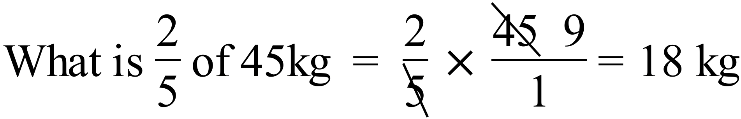
3. | 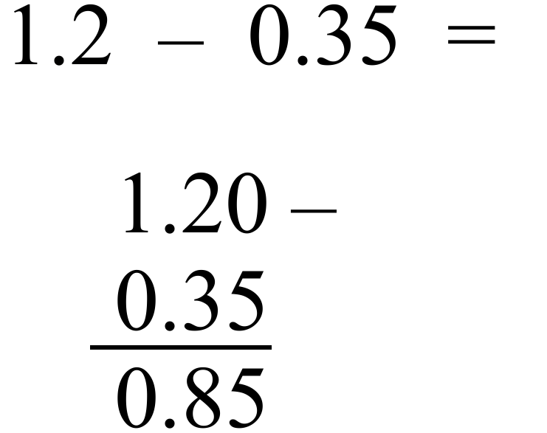
4. | 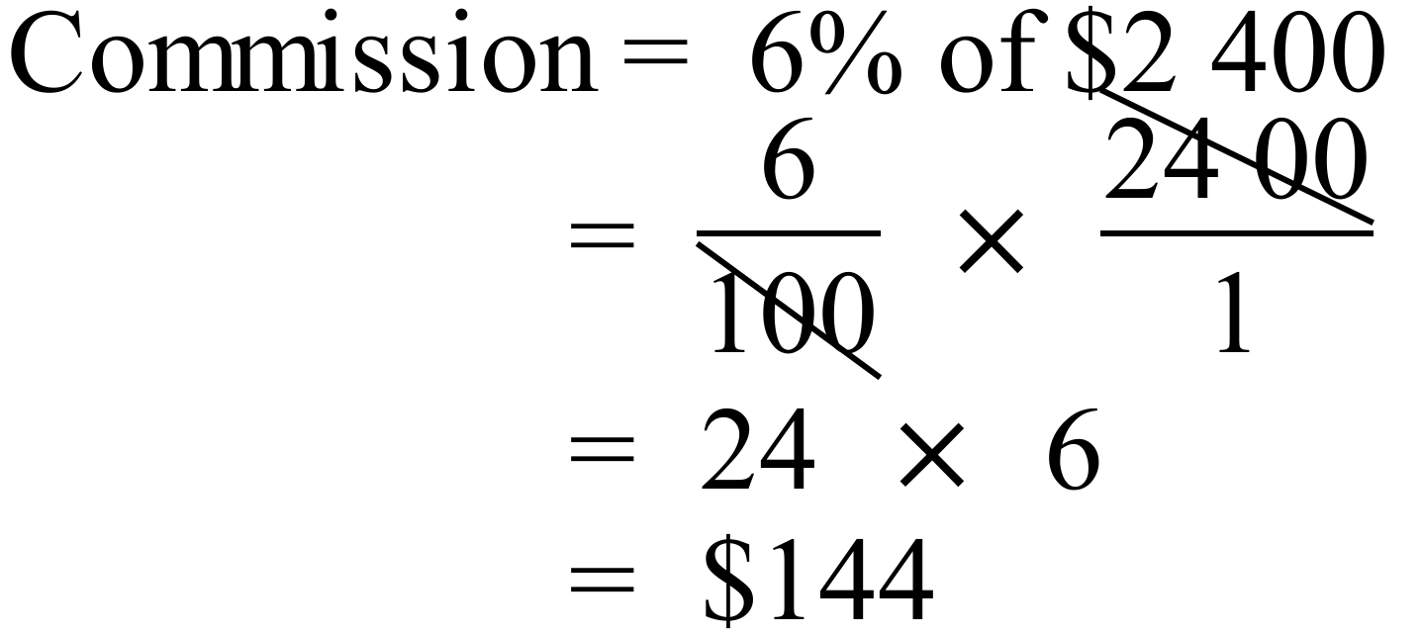
5. | 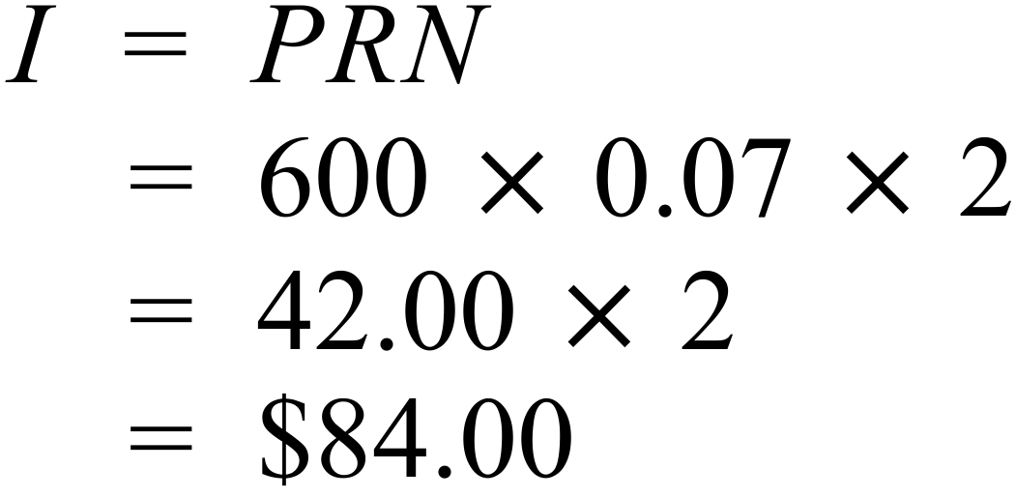
6. | 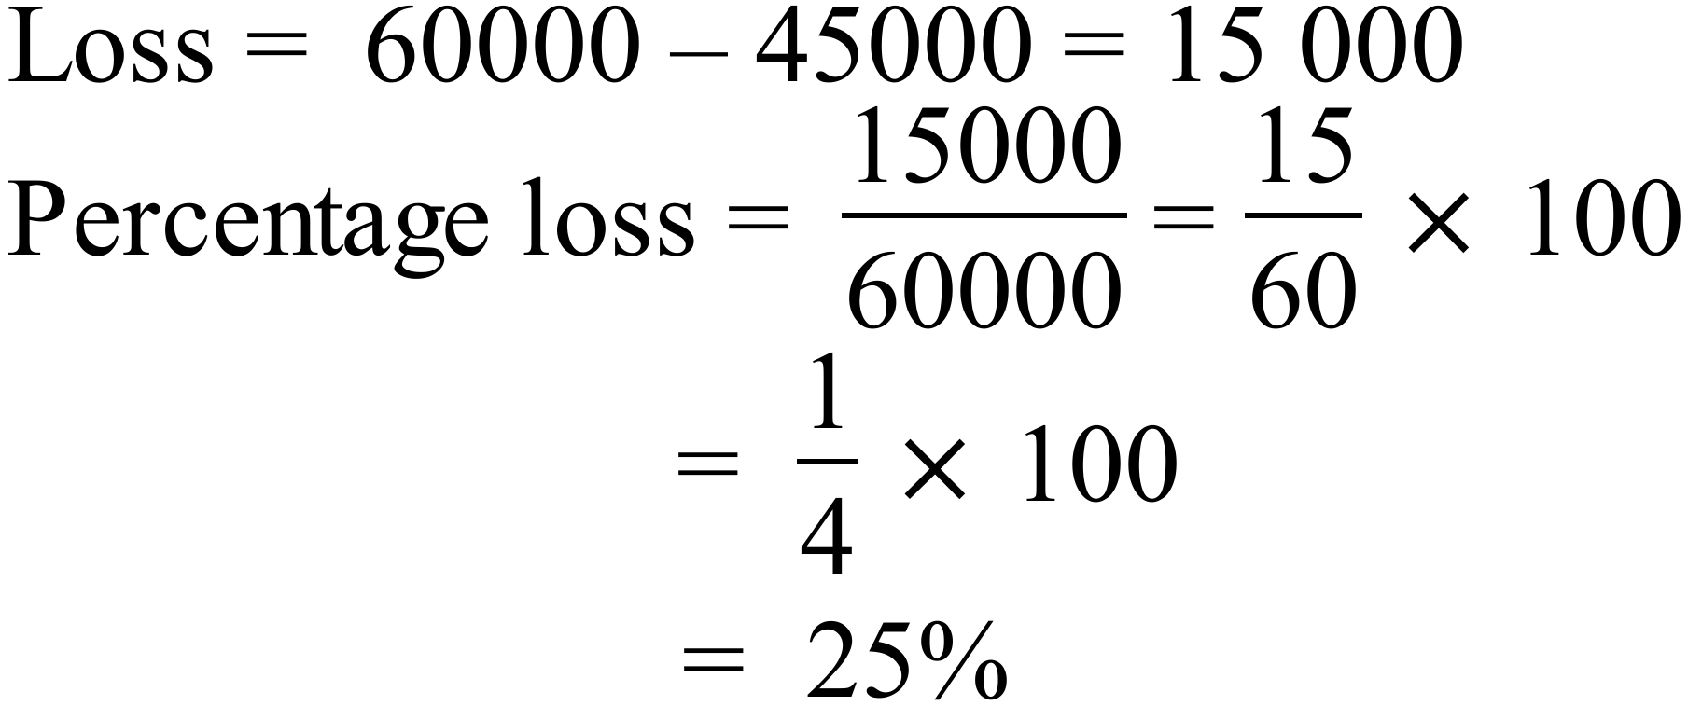
7. | 4.5 kilograms : 750 grams = 4500 g : 750 g  = 450 : 75  = 18 : 3  = 6 : 1
8. | What is the value of x in the diagram?  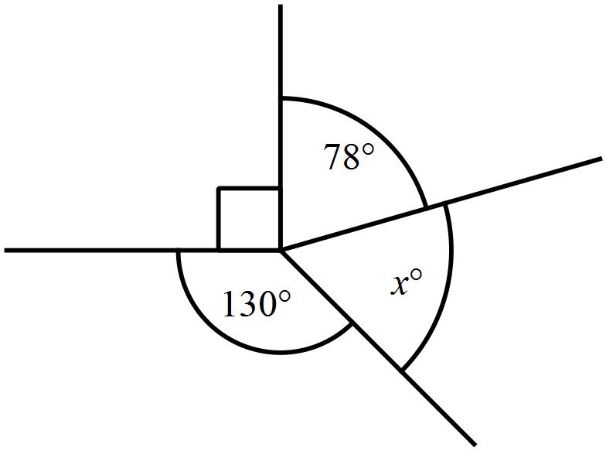  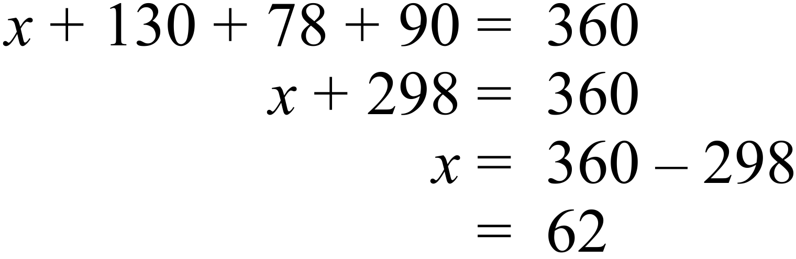
9. | The base angles xº are equal.  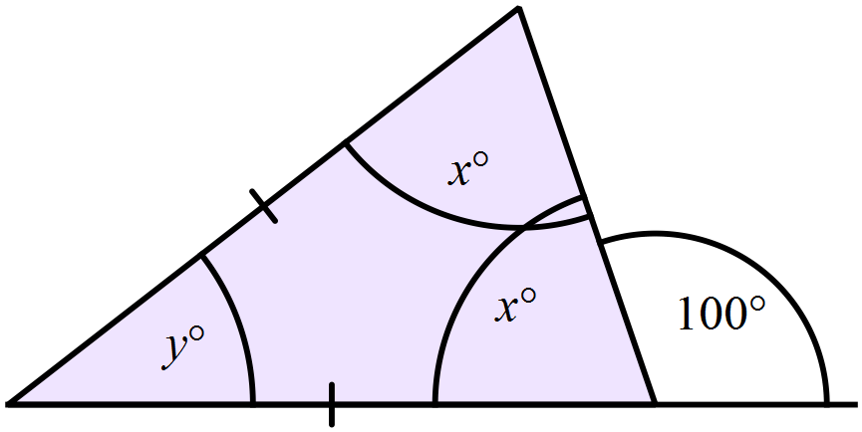  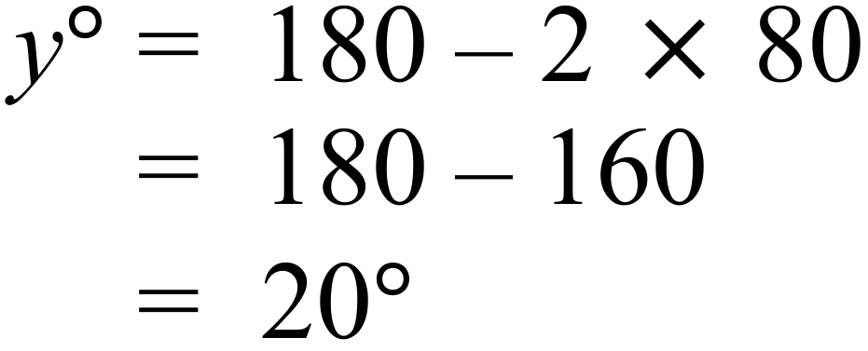
10. | The name is a RHOMBUS
   | Property | Yes /No
   | All sides equal | Y
   | All angles equal | N
   | Diagonals are equal | N
   | Diagonals intersect at right angles | Y
   | Axes of symmetry | Y (2)
11. | 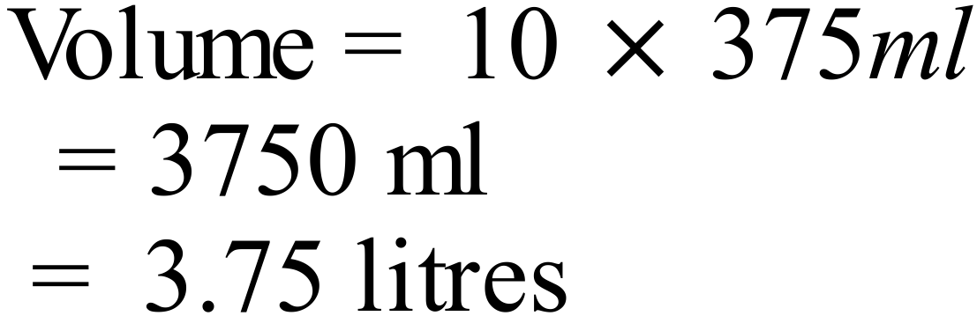
12. | 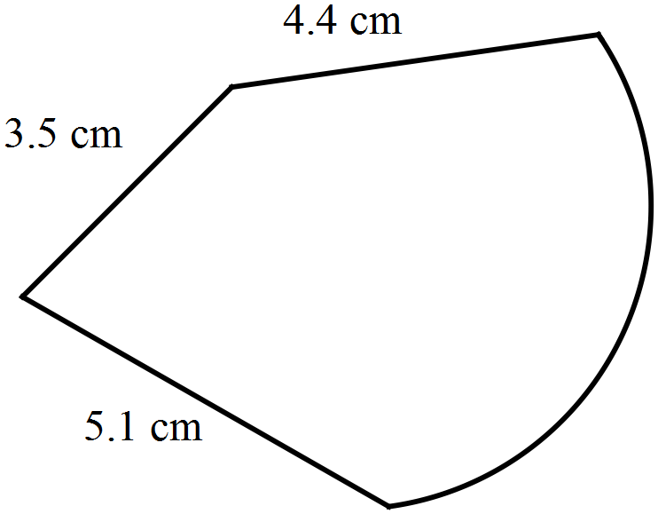  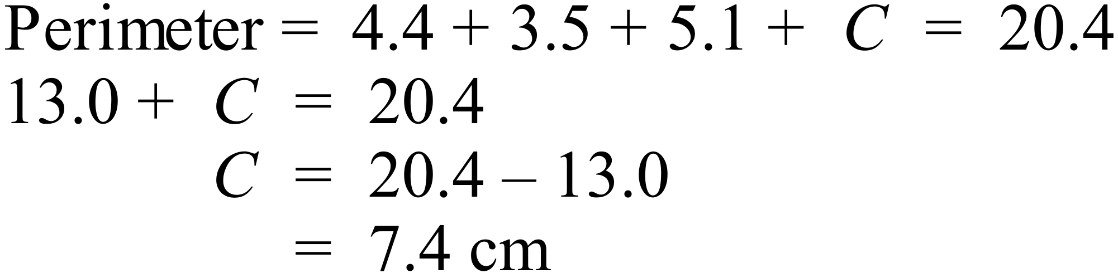
13. | 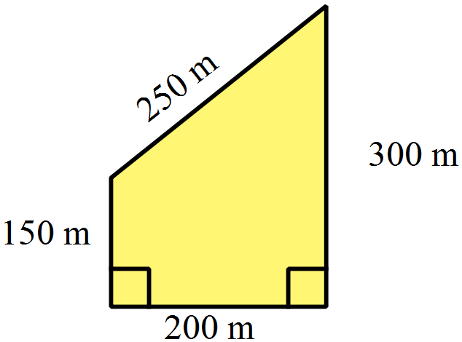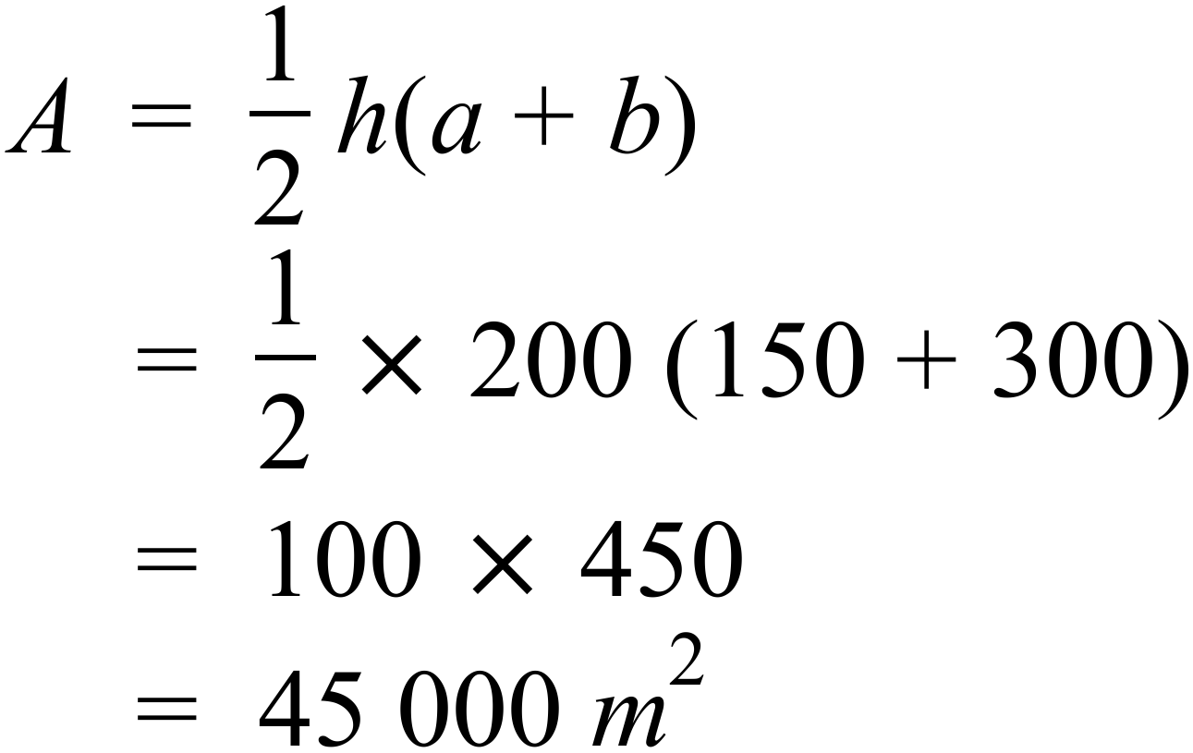
14. | 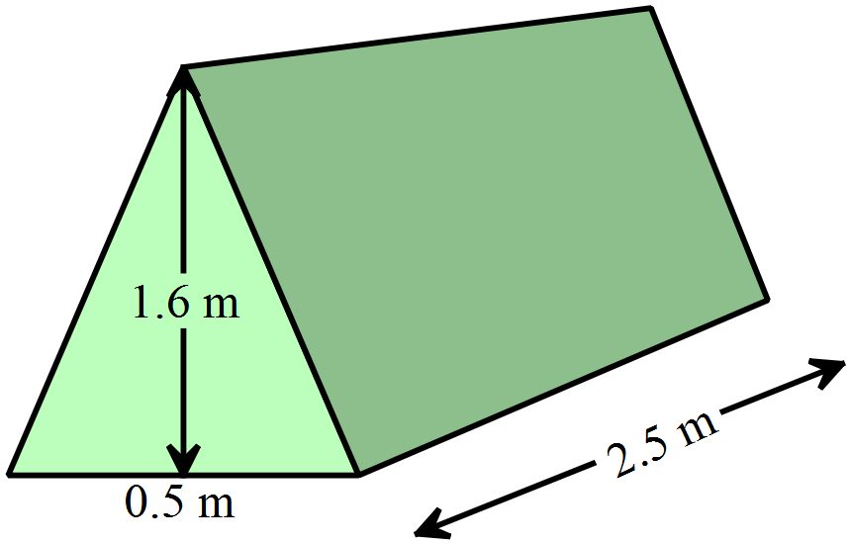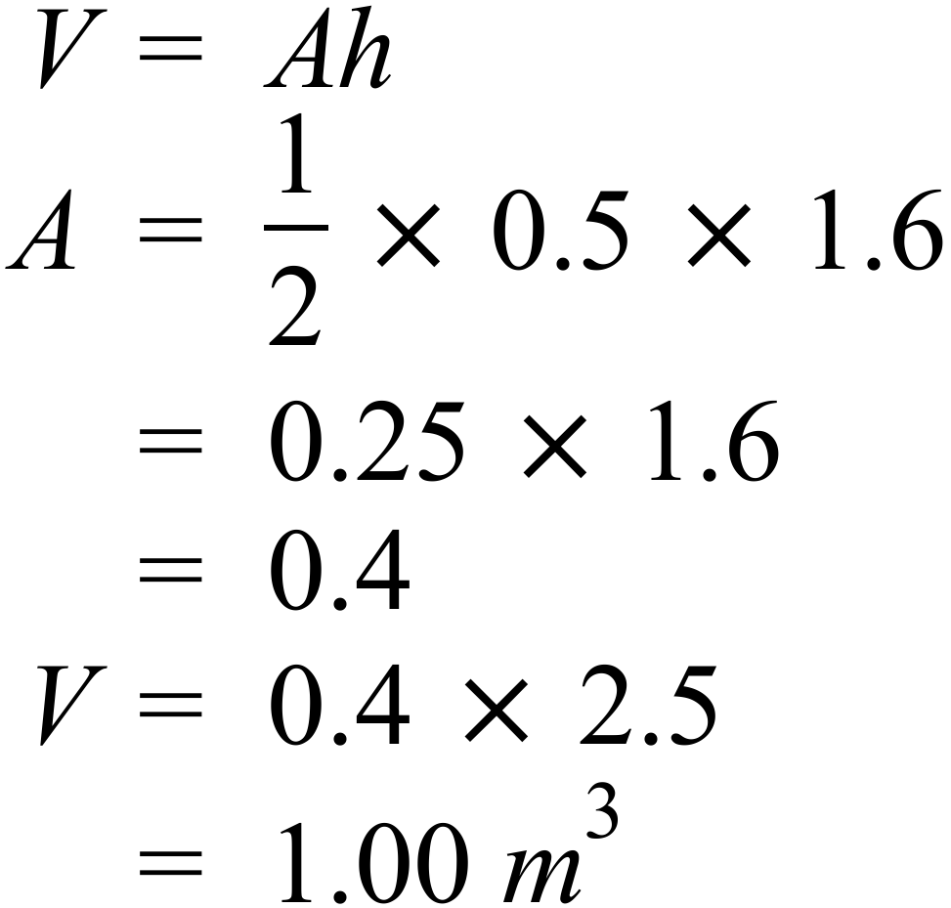
15. | 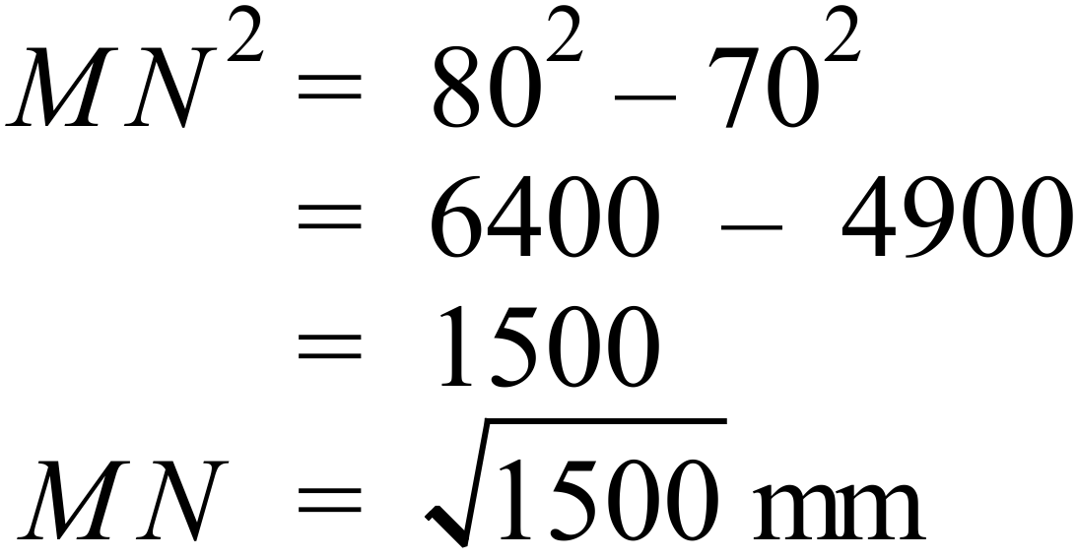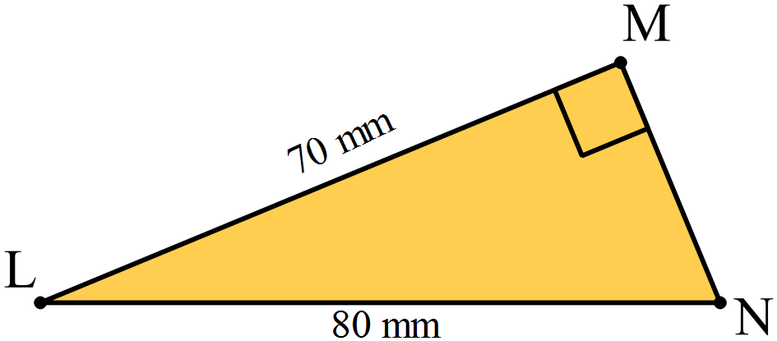
16.
17. | 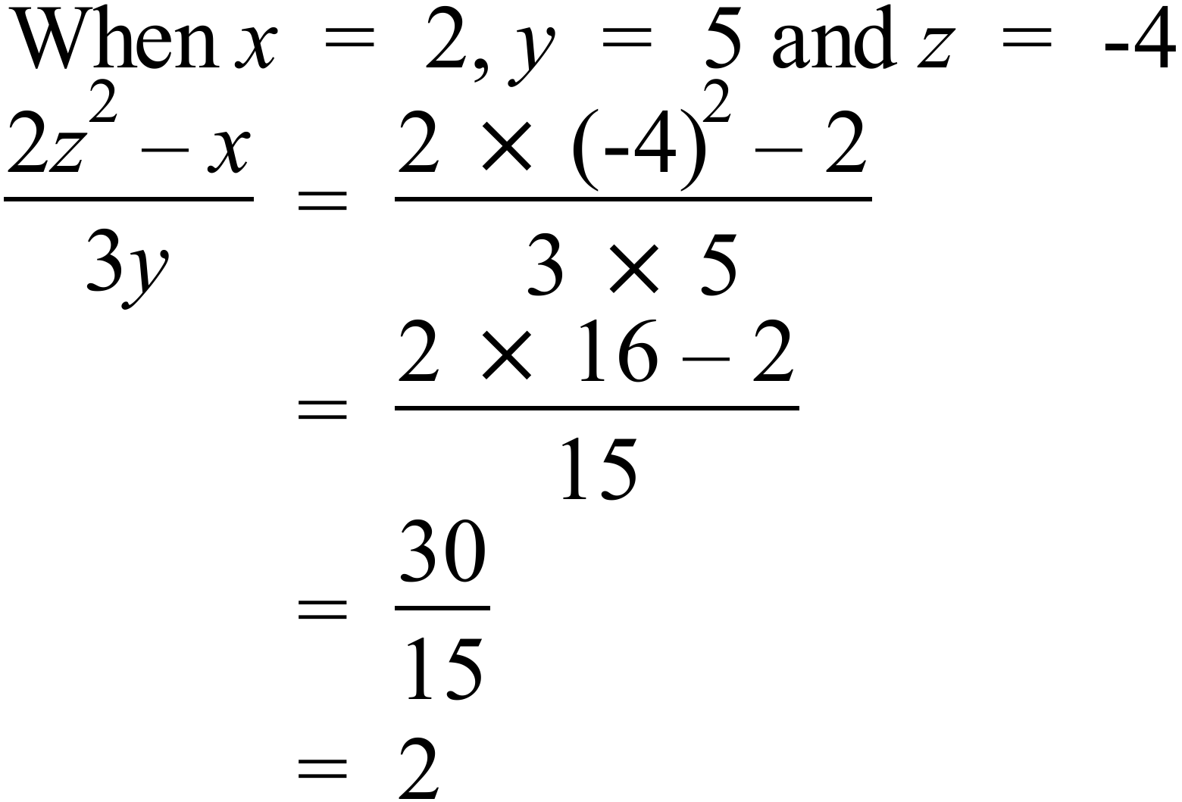
18. | 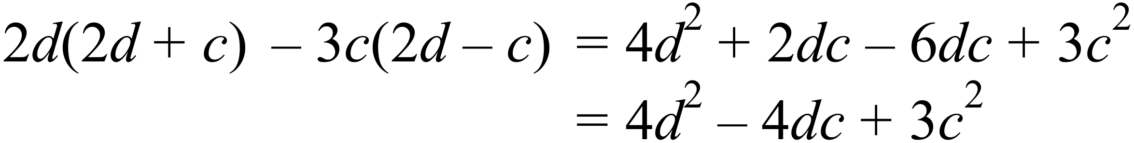
19. | 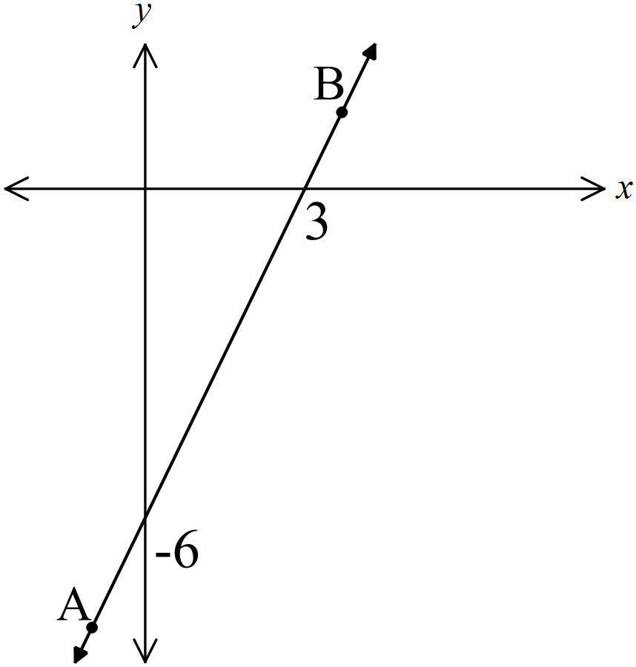 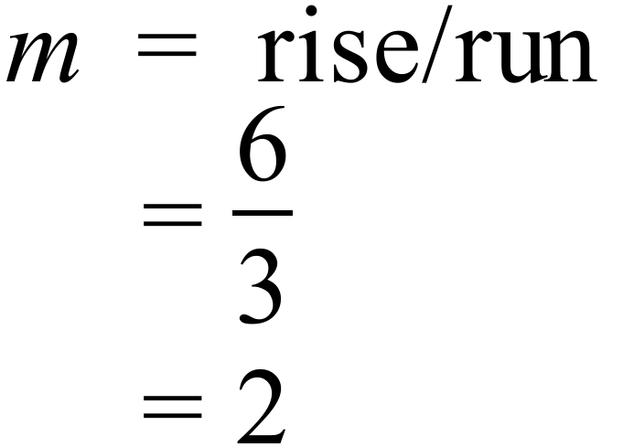 OR 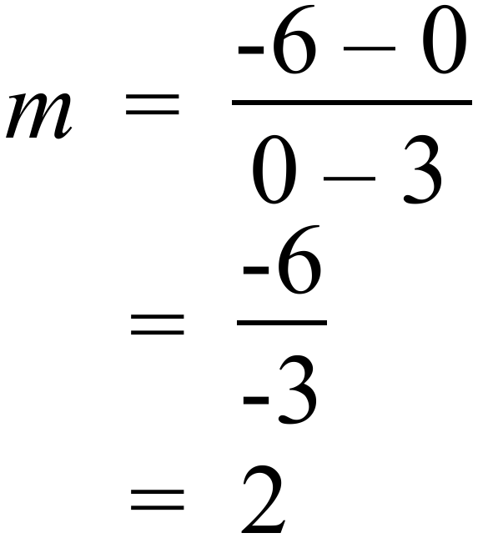
20. | 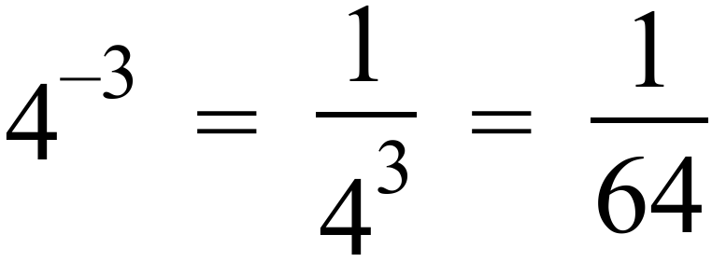
21. | Solve 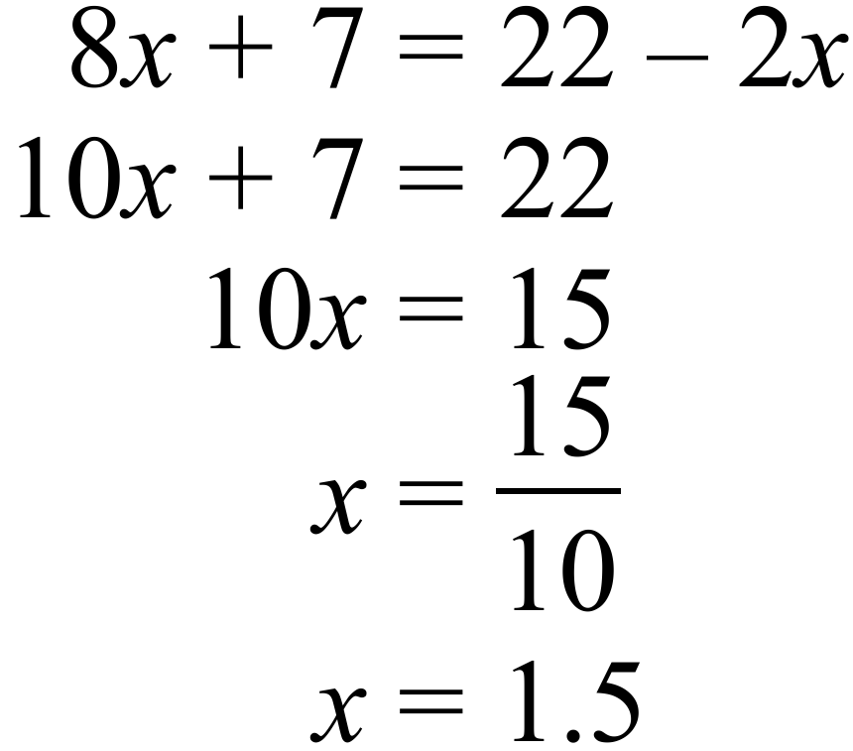
22. | 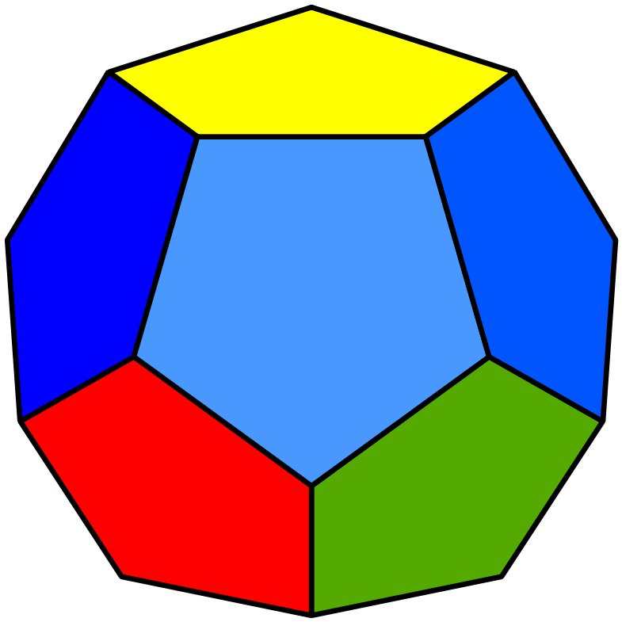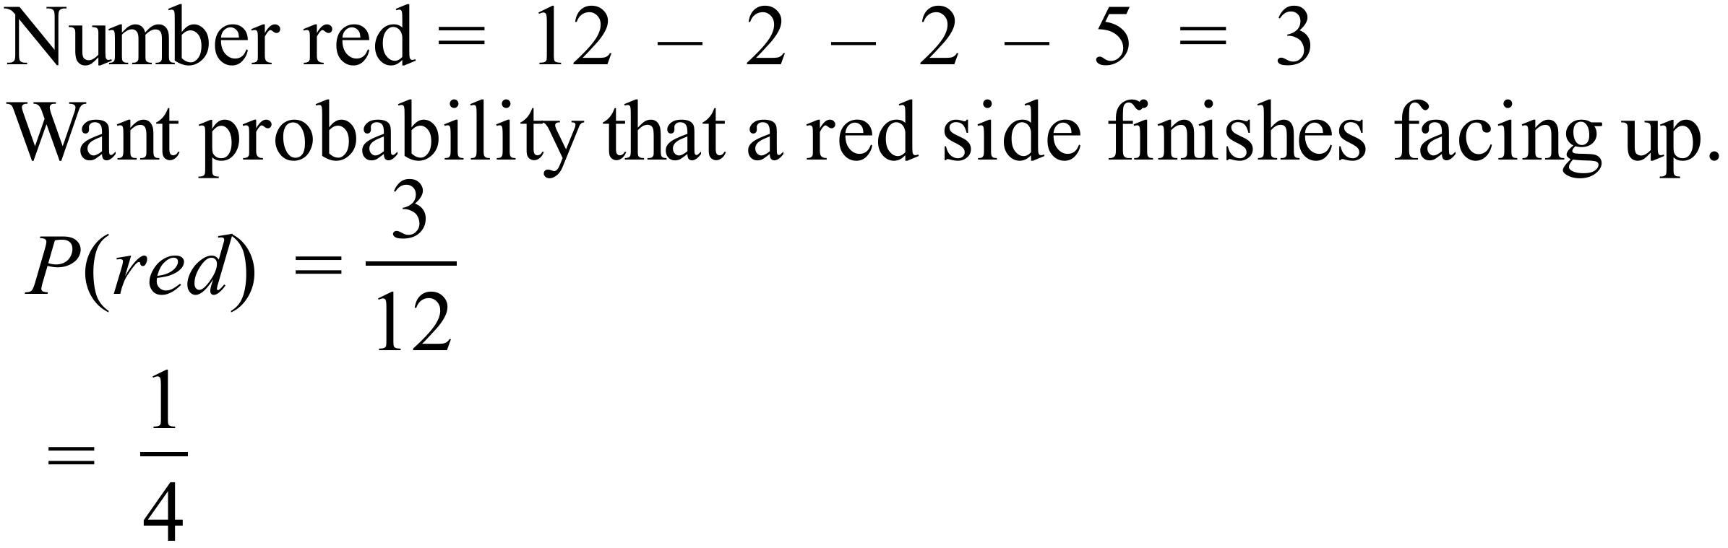
23. | Dance and Games are both 60º which is 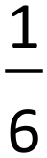 of his time.
24. | James spent 6 hours a week playing sport = 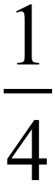 of total.  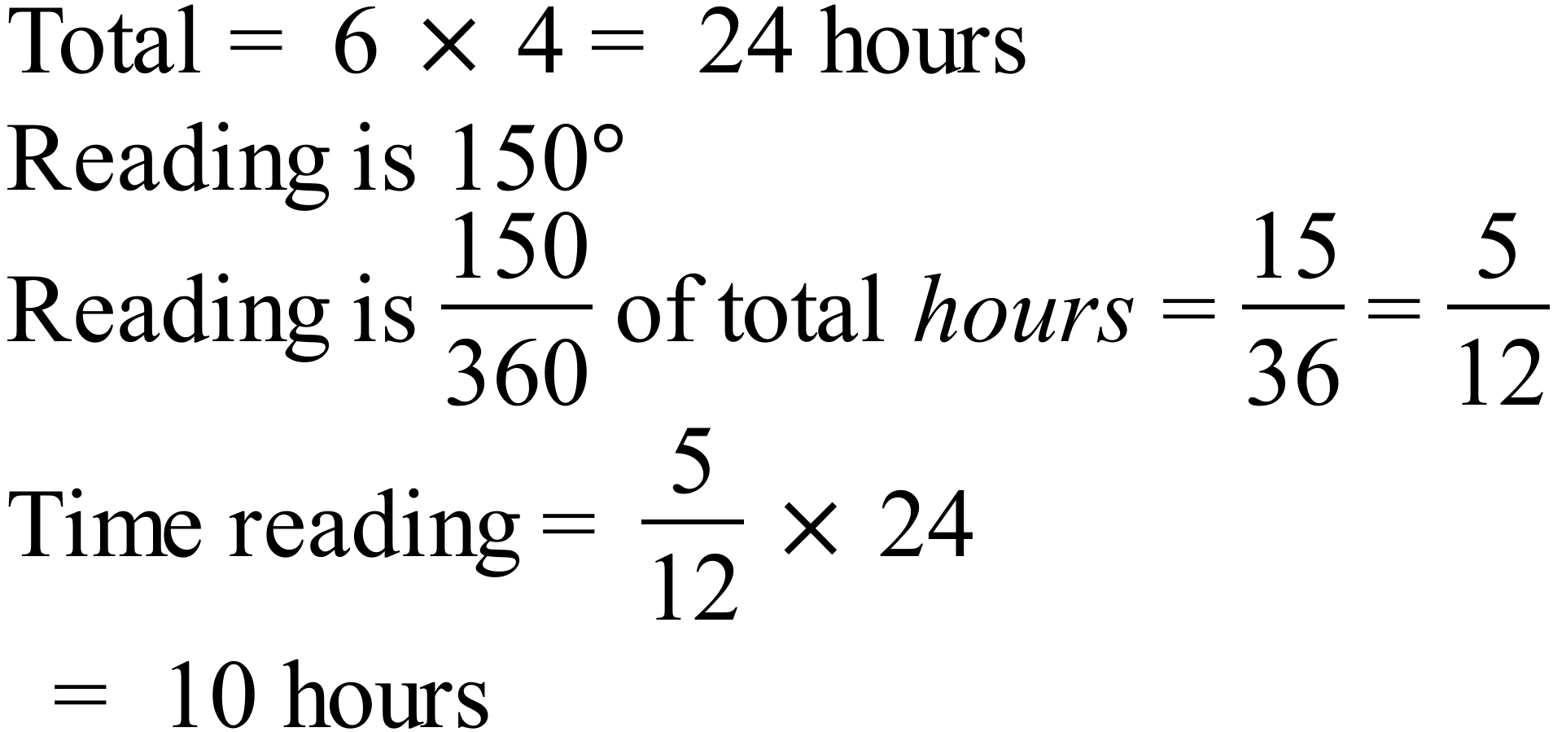
25. | From 20 scores median between 10th and 11th so between 2 and 3. Median = 2.5
   |  |  | O
  O |  | O | O
  O |  | O | O | O
  O | O | O | O | O
  O | O | O | O | O | O |  |  | O
  0 | 1 | 2 | 3 | 4 | 5 | 6 | 7 | 8

Multiple Choice Questions
 | ⌂ = 7 and □ = 6 | A
  7 | 4 | 5 | –
  2 | 6 | 8
  4 | 7 | 7
 | 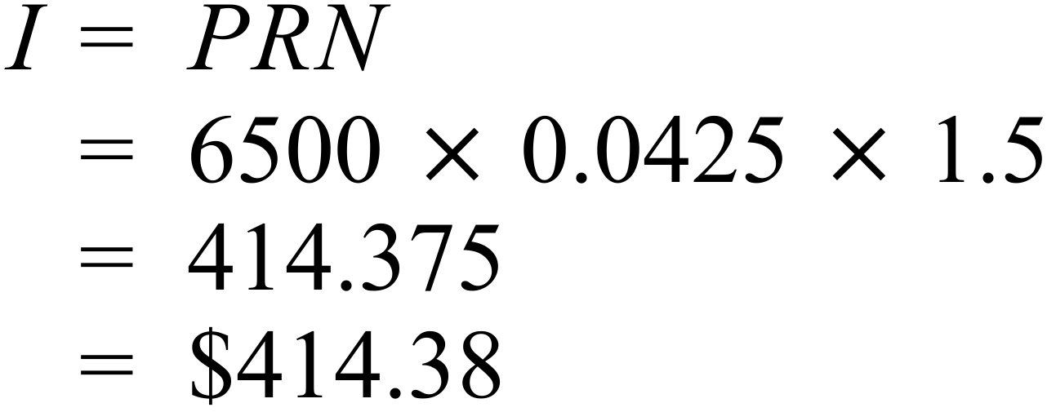 | A
 | 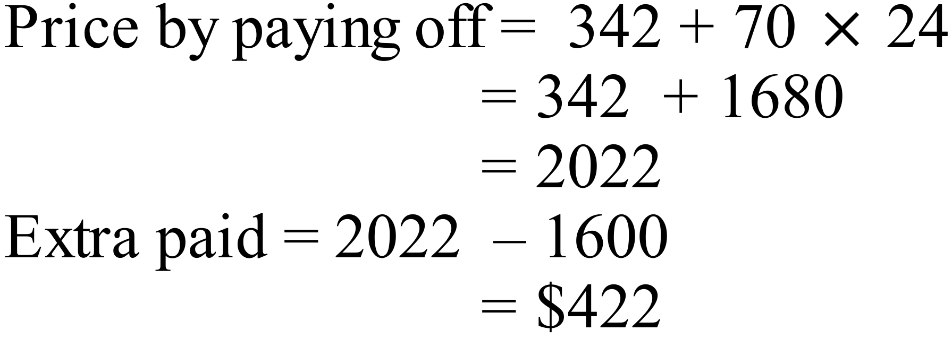 | B
 | 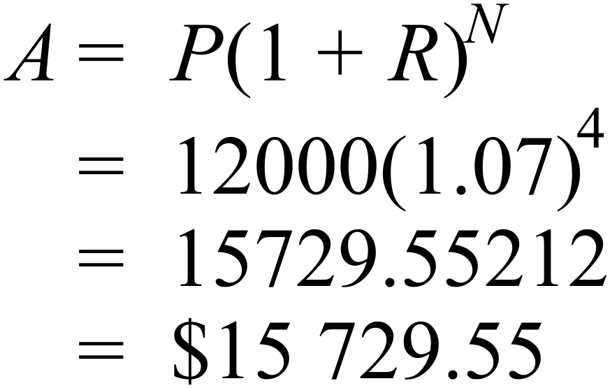 | D
 | Half is $1250.   | A
 | 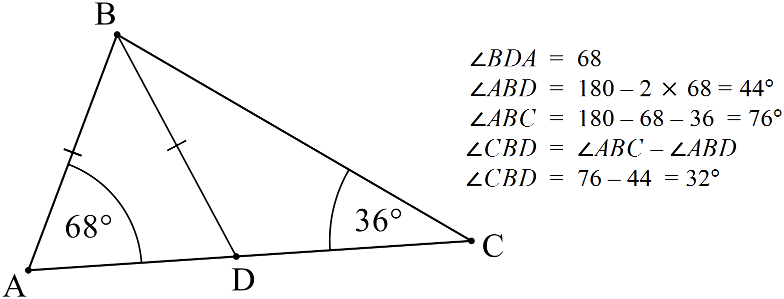 | A
 | 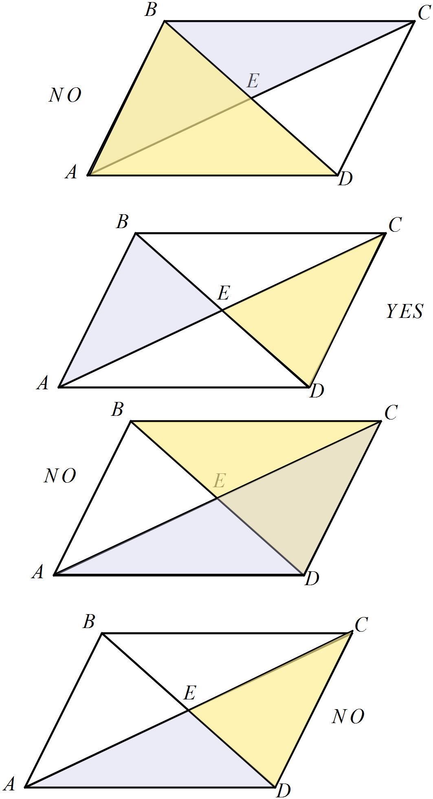  B. 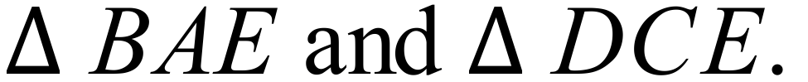 | B
 | 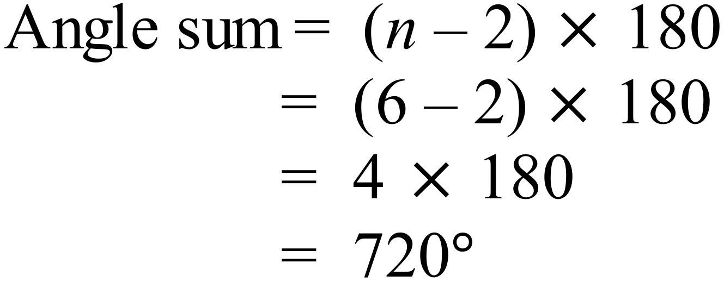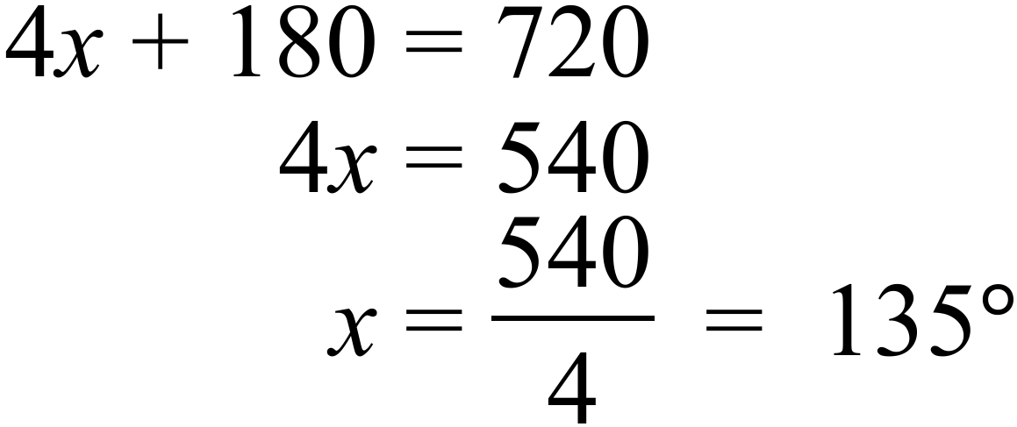 | C
 | 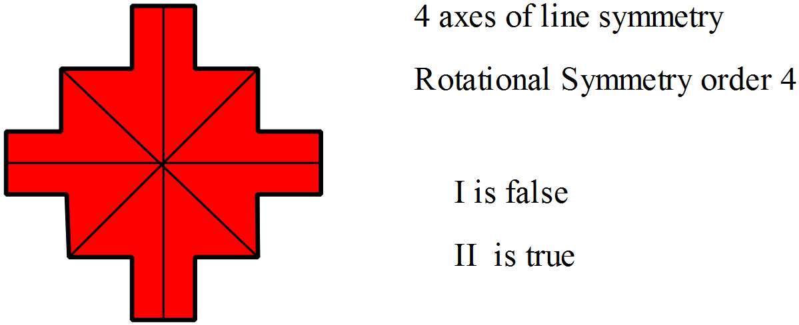 | D
 | 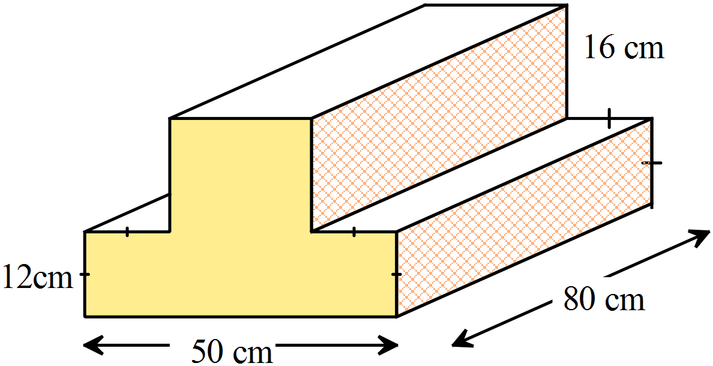  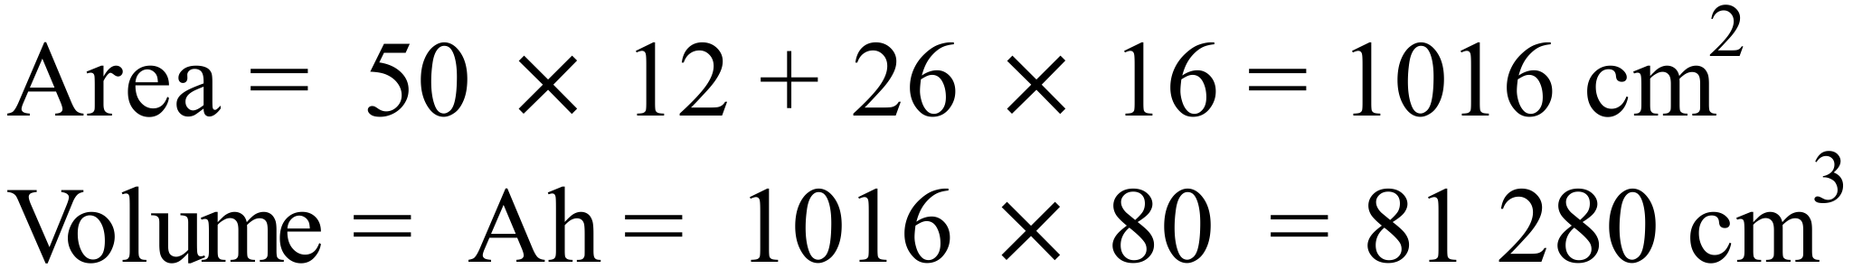 | D
 | 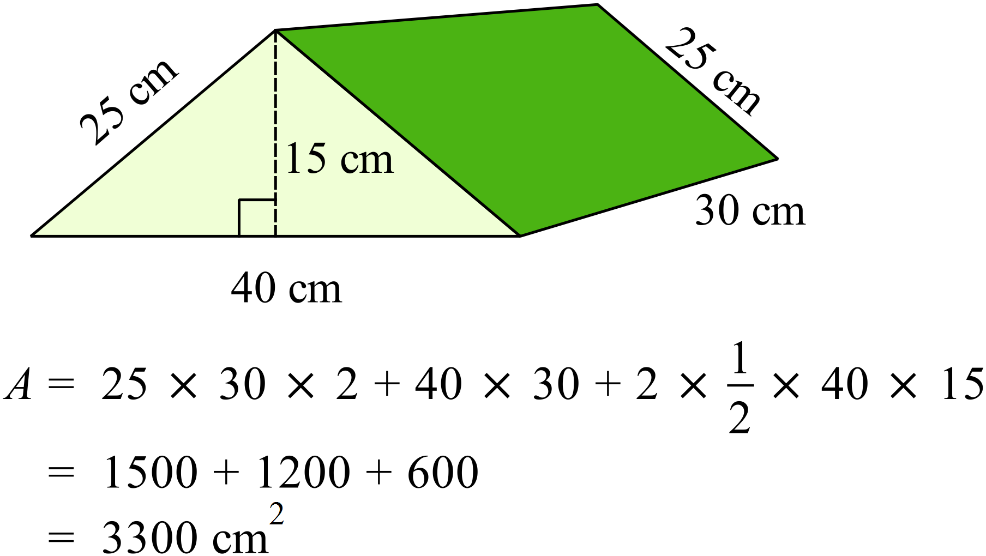 | C
 | 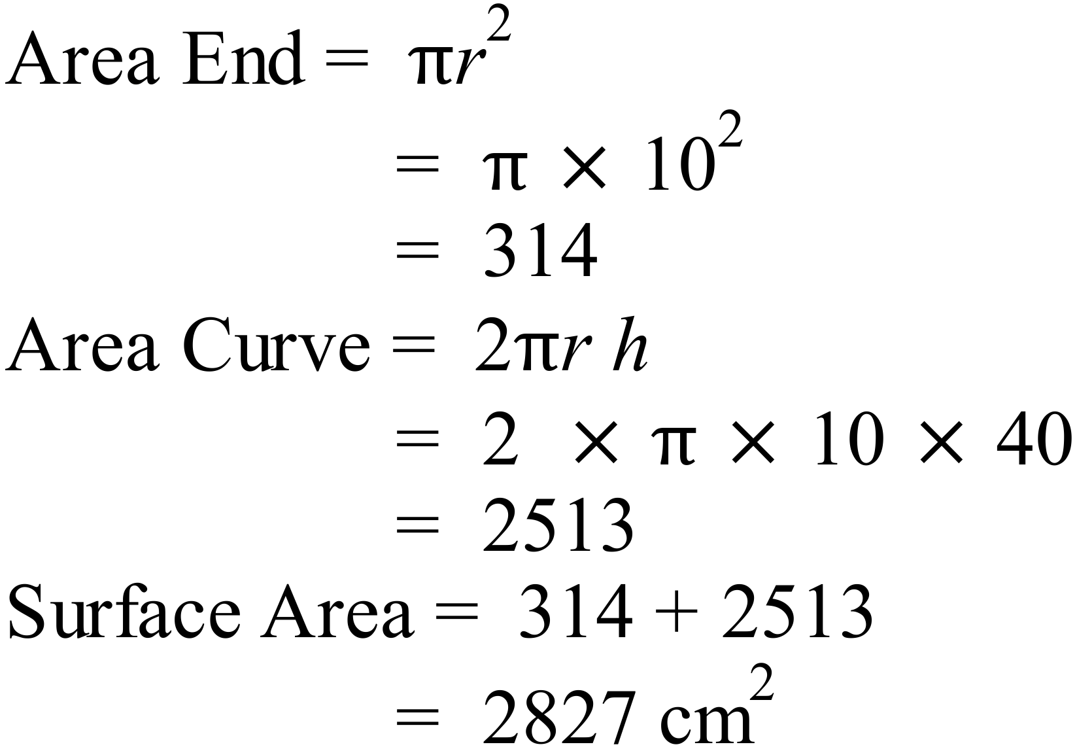 | C
 | 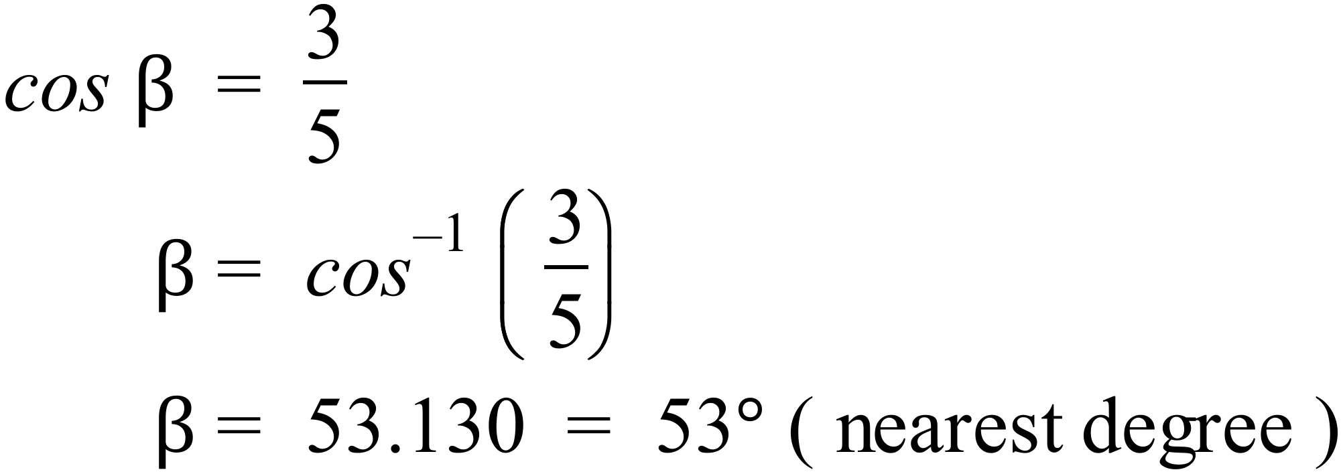 | C
 | 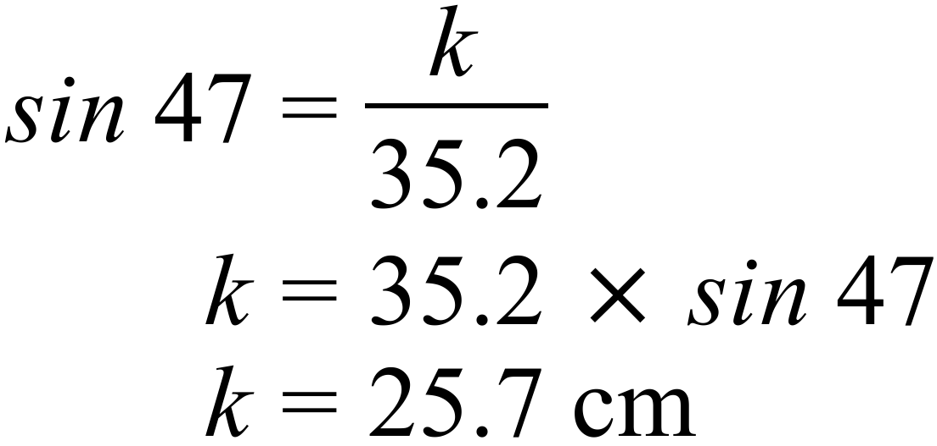 | A
 | 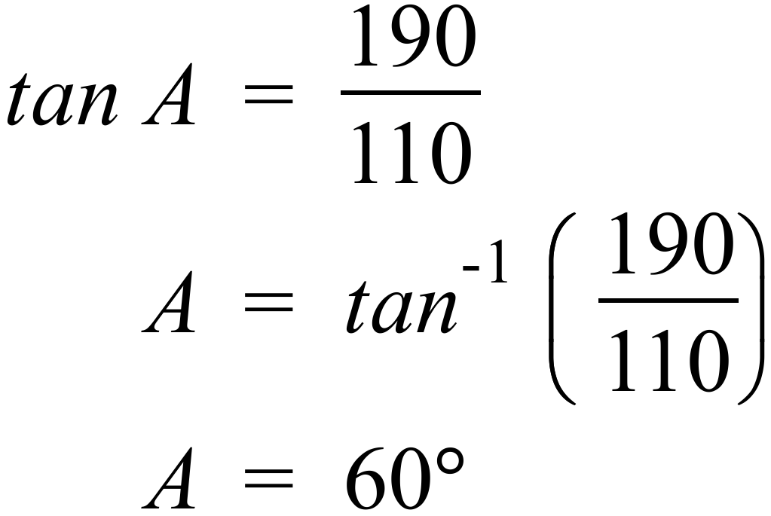 | B
 | 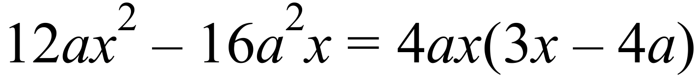  So the first three are all factors but D is not. | D
 | 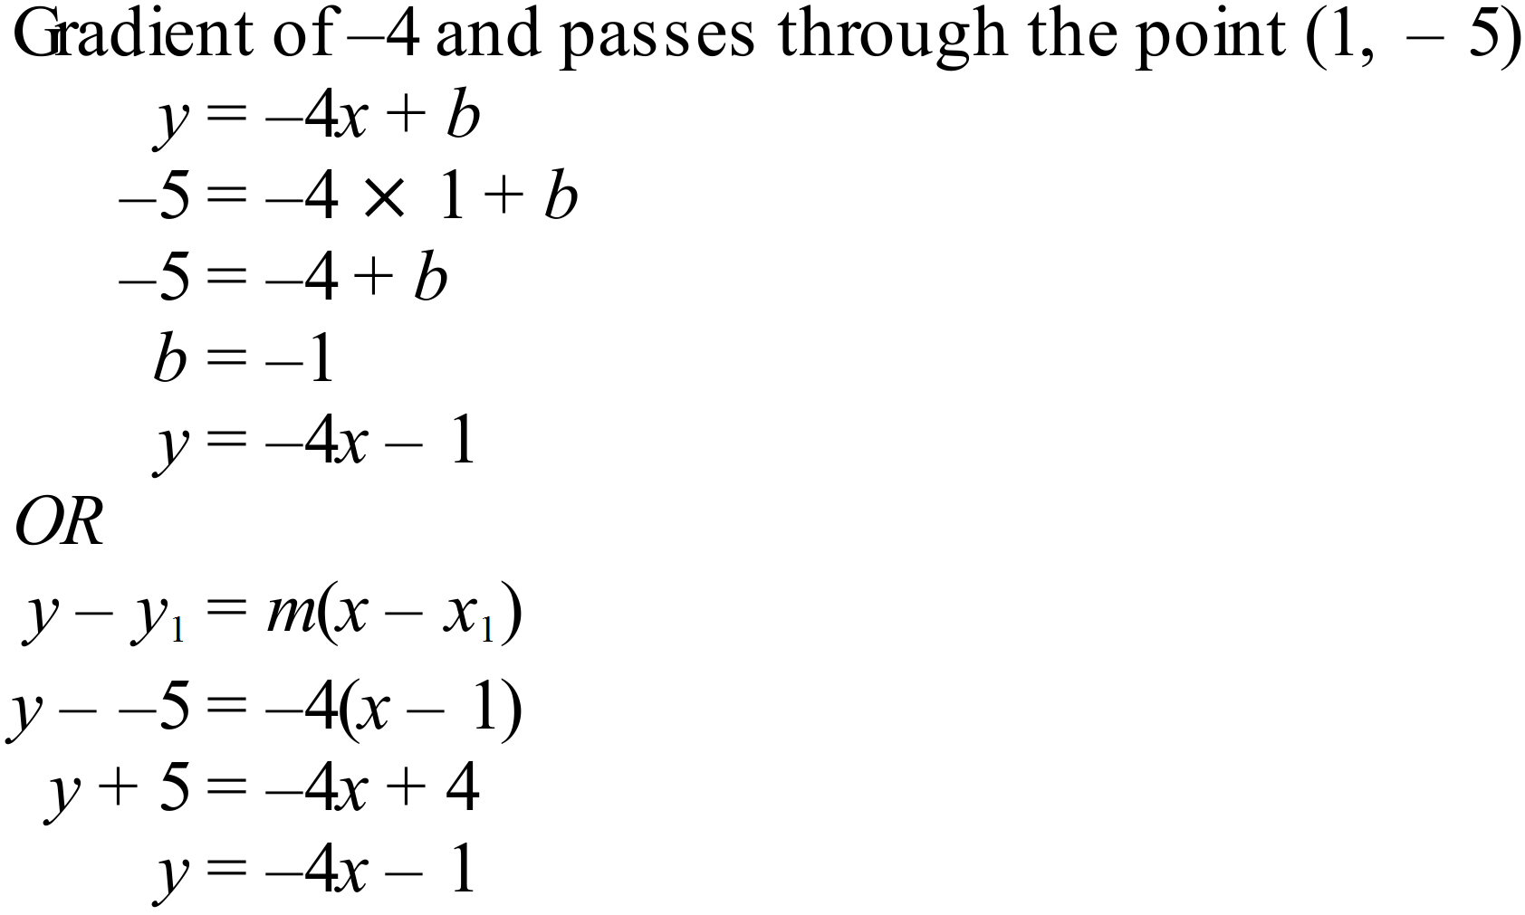 | C
 | 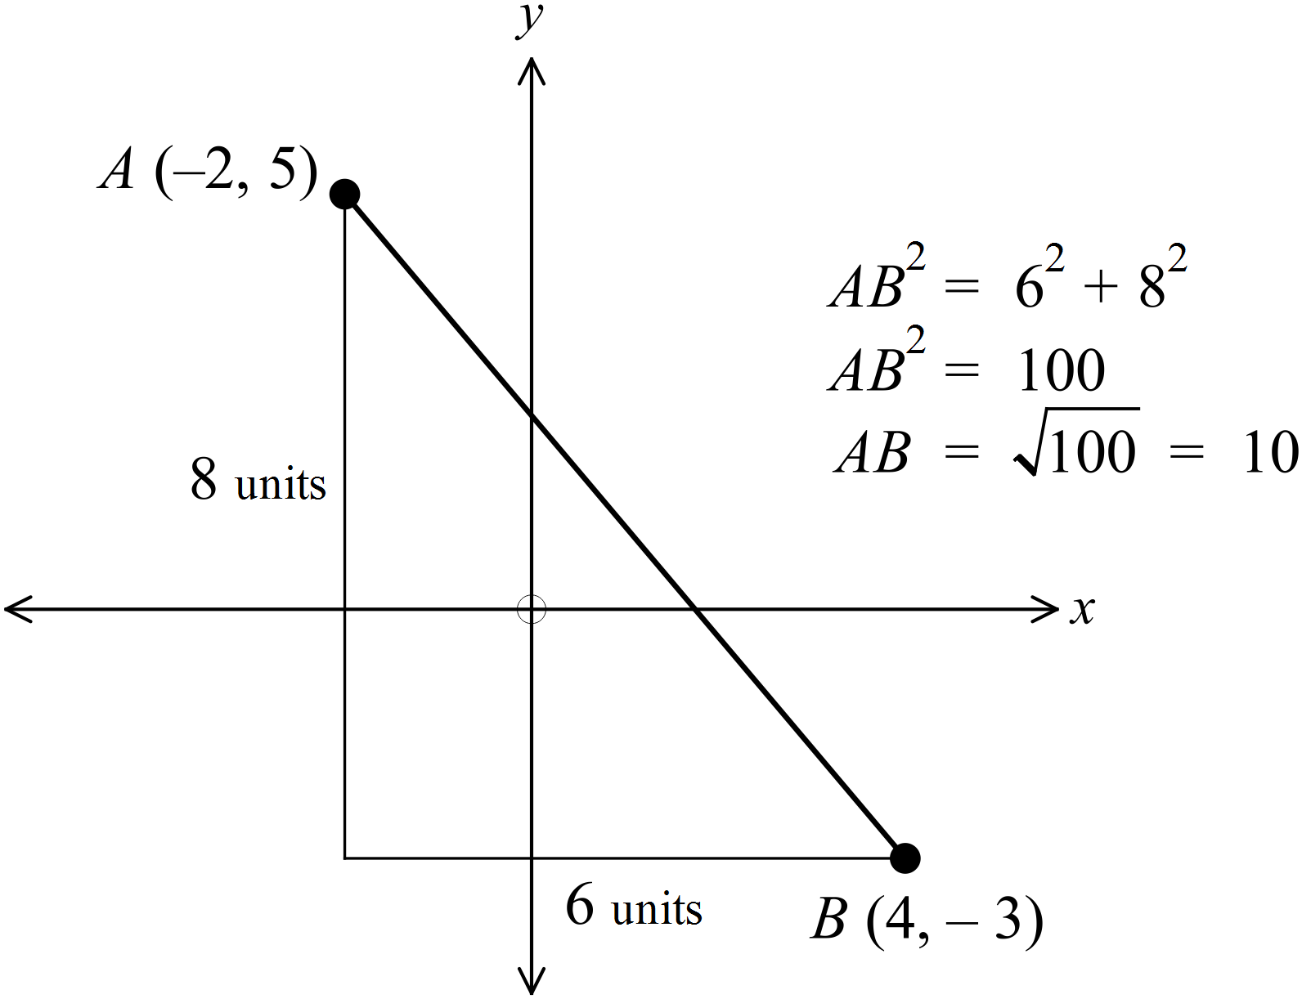 | D
 | 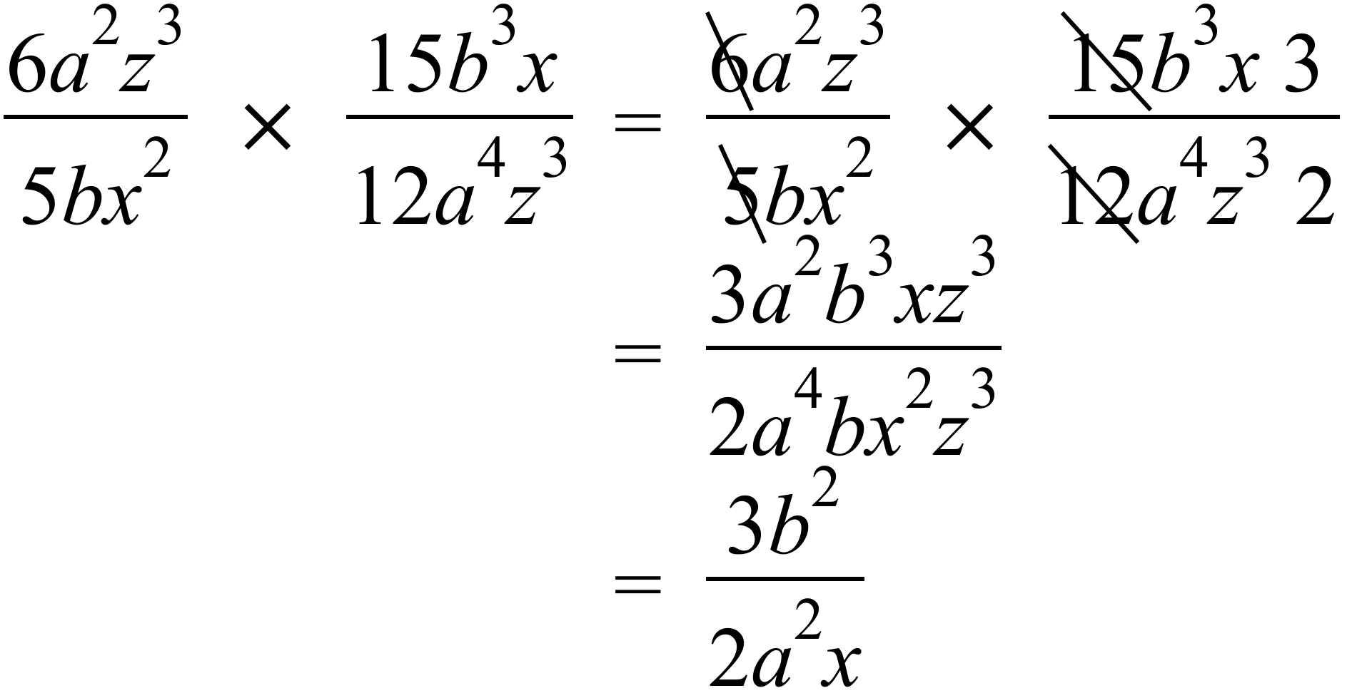 | C
 | 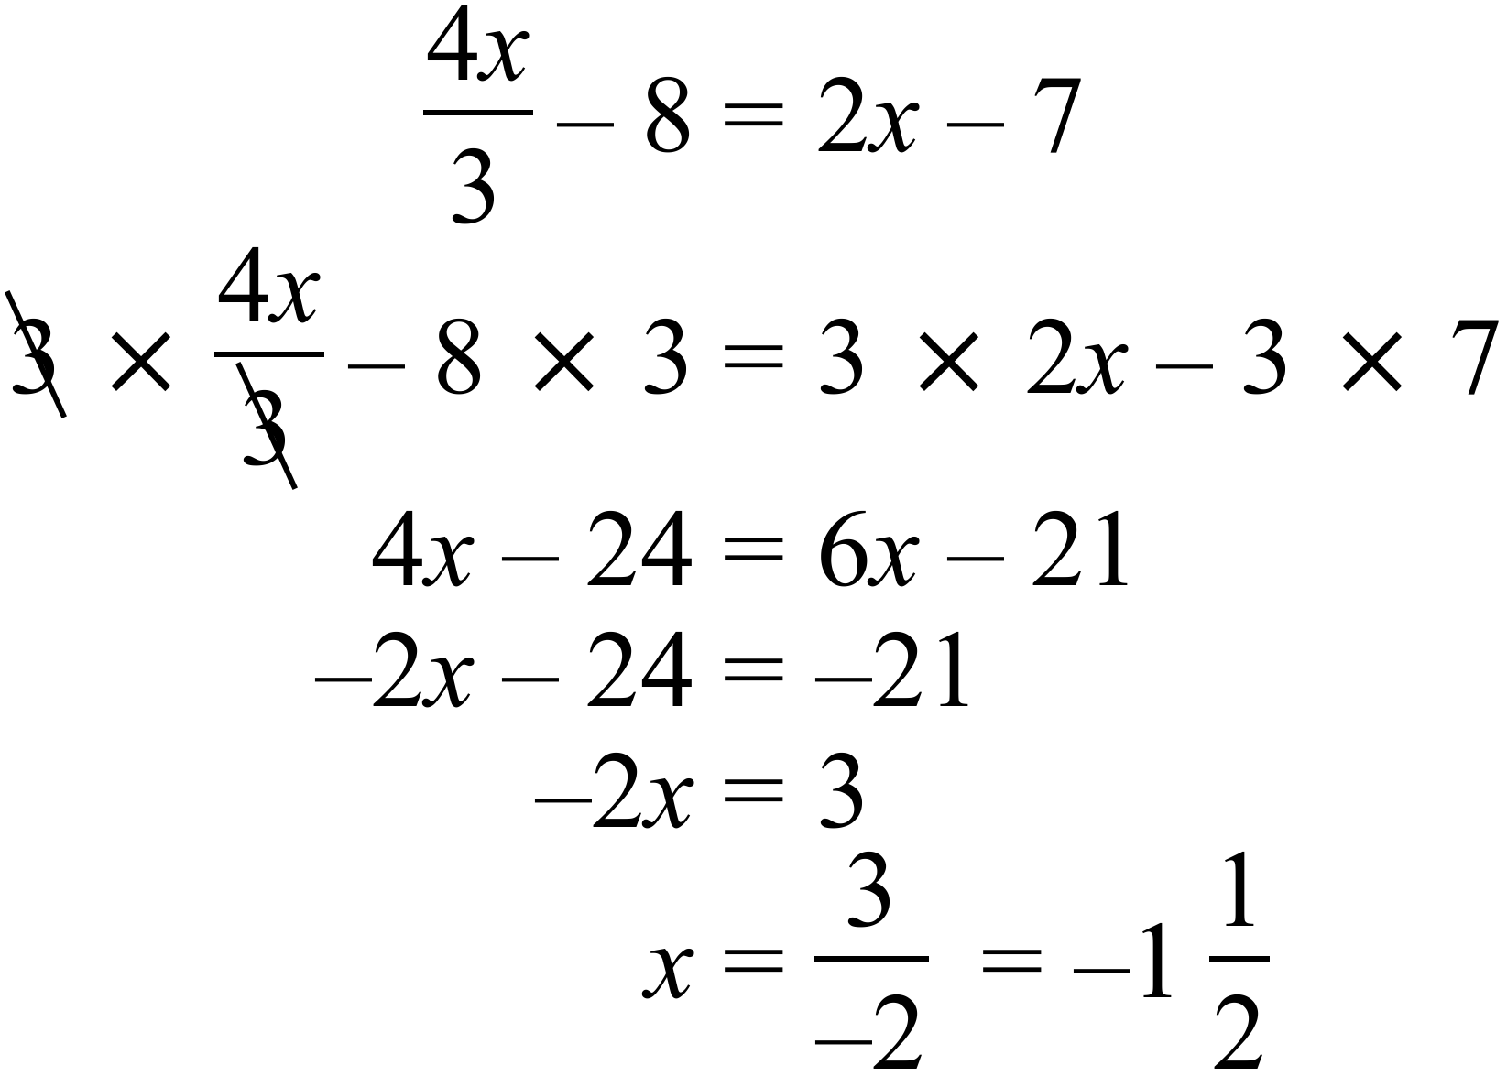 | A
Ages of Emattogah Cricket Players
1 | 4 | 5 | 6 | 6 | 8 | 9
2 | 0 | 2 | 4 | 6 | 7 | 9 | 9 | 9
3 | 1 | 3 | 4 | 5 | 5 | 7
4 | 2 | 6
5 | 3

 | Counting the leaves, there are 23. | B
 | From 23 the middle is the 12th leaving 11 above and 11 below. The 12th score is 29 | C
 | From the upper 11 scores the middle is the 6th of these leaving 5 above and 5 below, 6th from top is the 18th score which is 35. | B
 | O |  |  |  |  |  | O
 | O |  |  |  |  |  | O
 | O | O |  |  |  | O | O
O | O | O | O |  | O | O | O | O
O | O | O | O | O | O | O | O | O
1 | 2 | 3 | 4 | 5 | 6 | 7 | 8

 | It is both Bimodal (2 and 8) and symmetrical. | B
 | From observation mean = 5, median = 5,  modes = 2 and 8 and range = 9 - 1 = 8  Mean and median are equal. | C
51. | Compounding monthly at 6% p.a. for 1.5 years  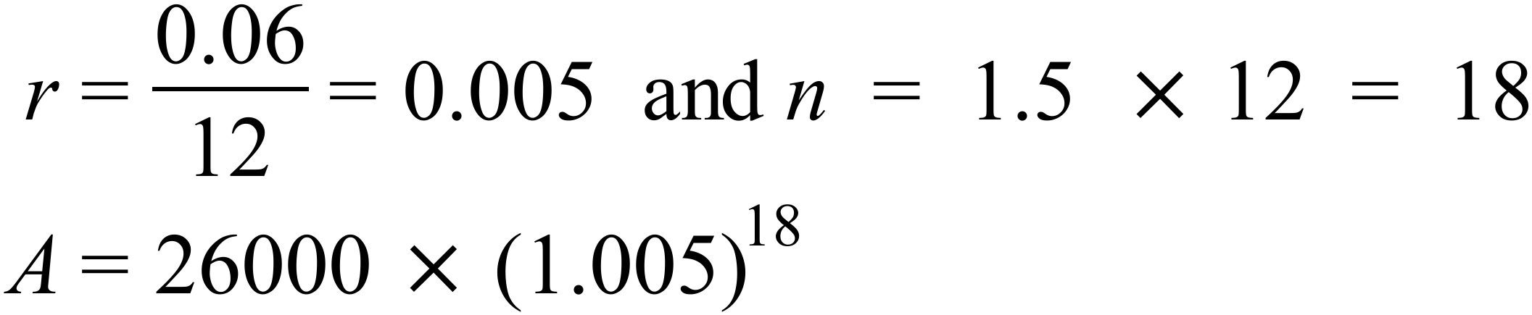 | C
52. | 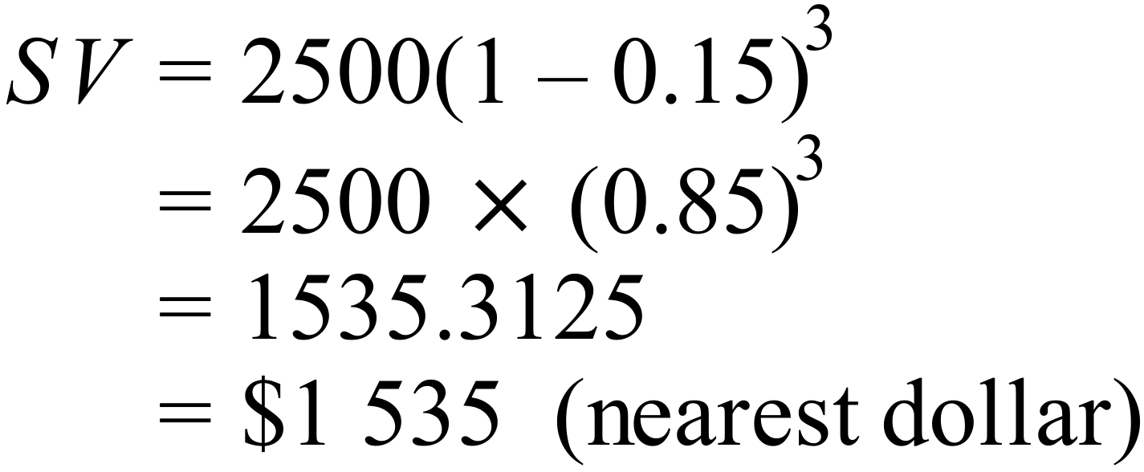 | C
53. | 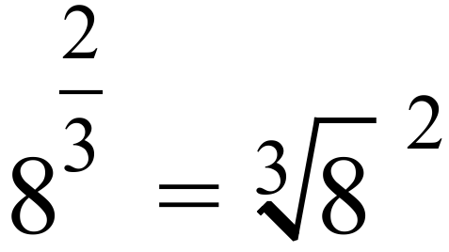 | D
54. | 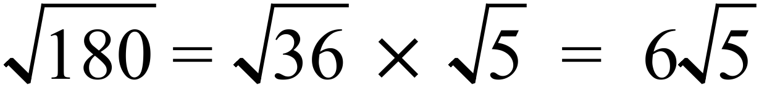 | B
55. | 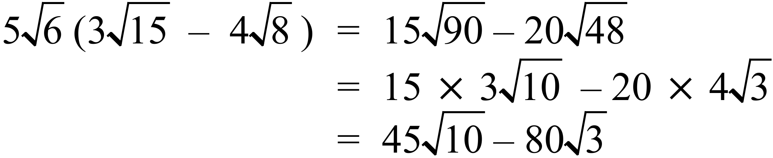 | D
56. | 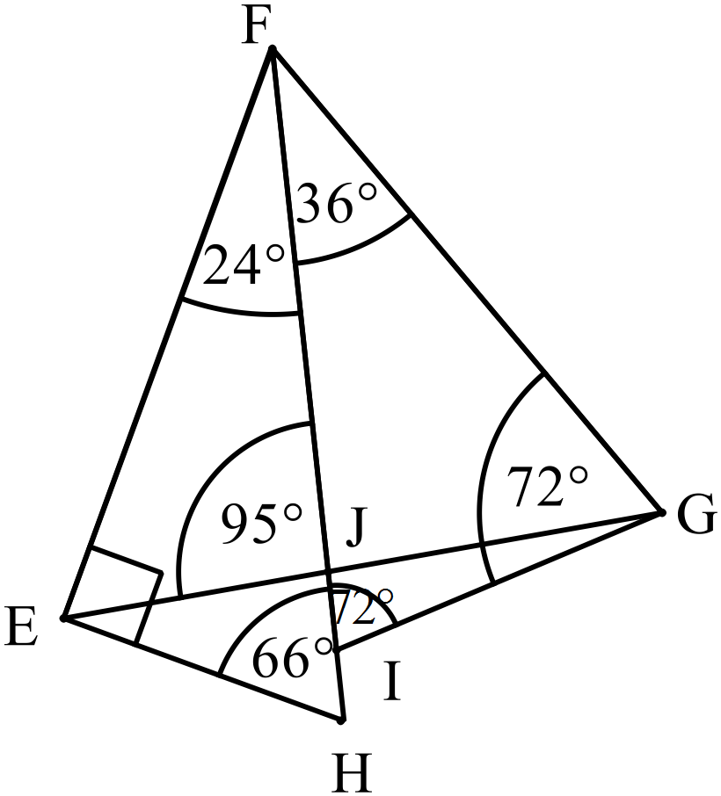 | A
57. | 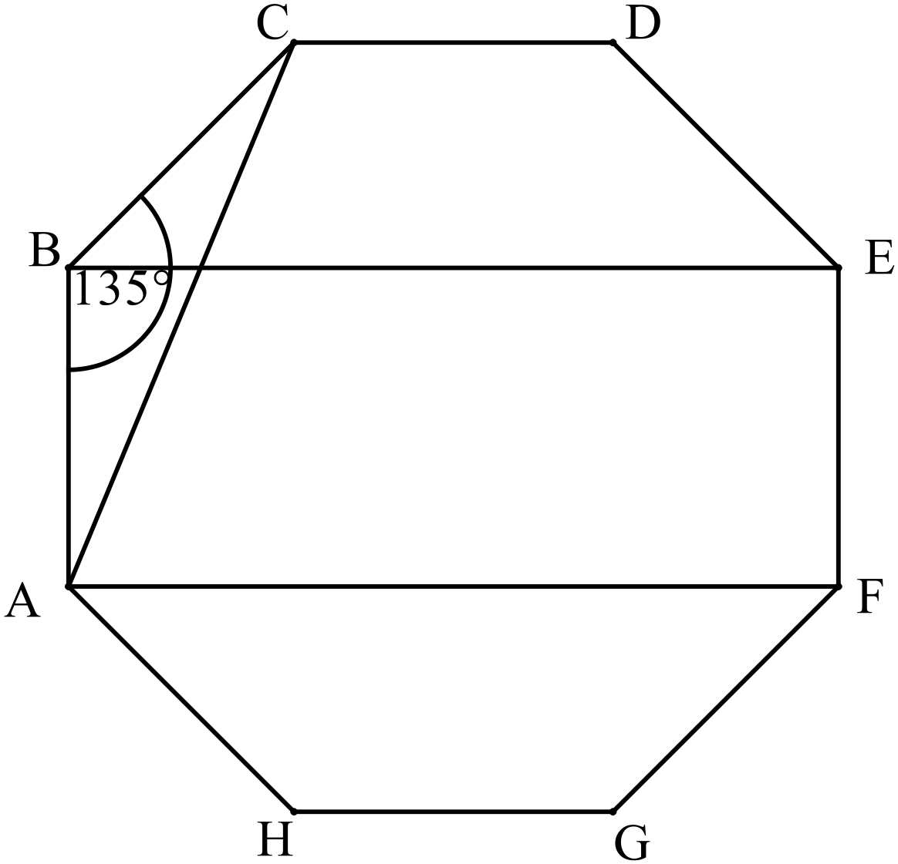B is not true. | B
58. | 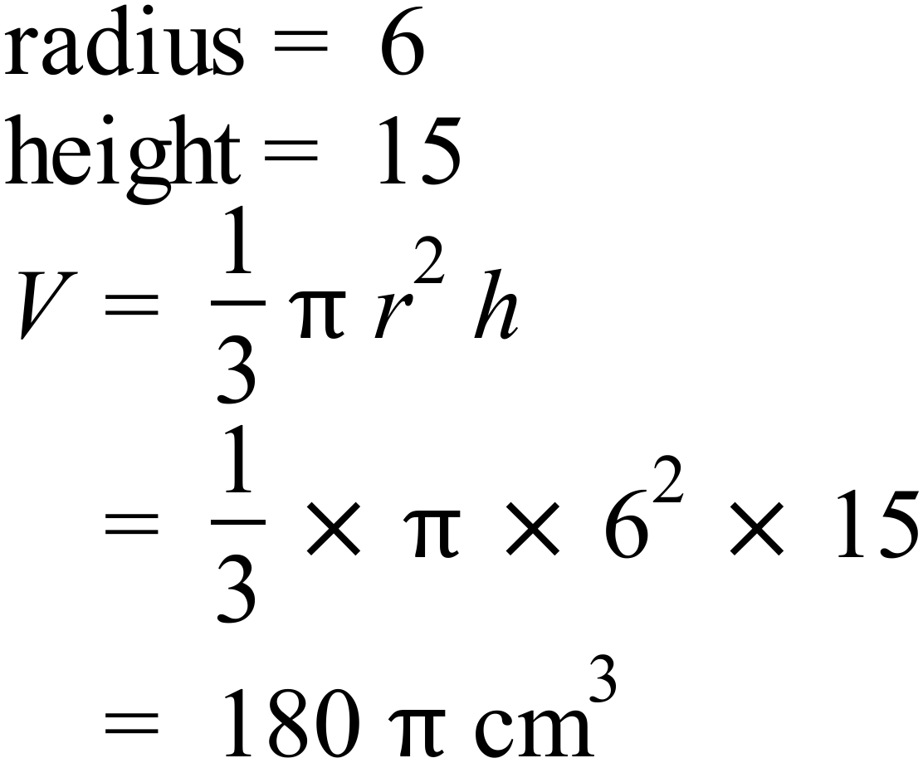 | A
59. | 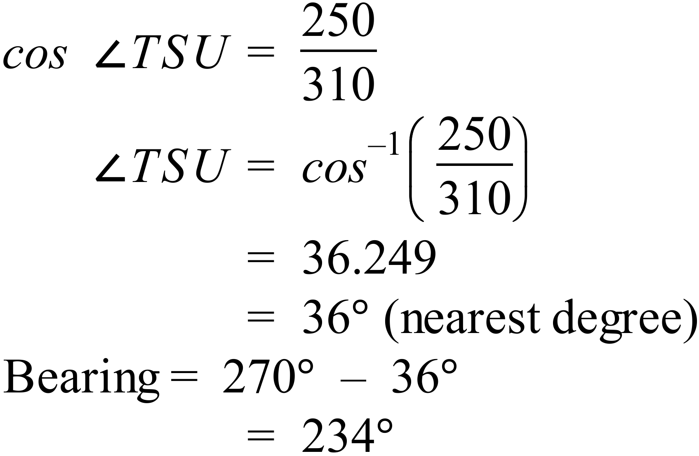 | C
60. | 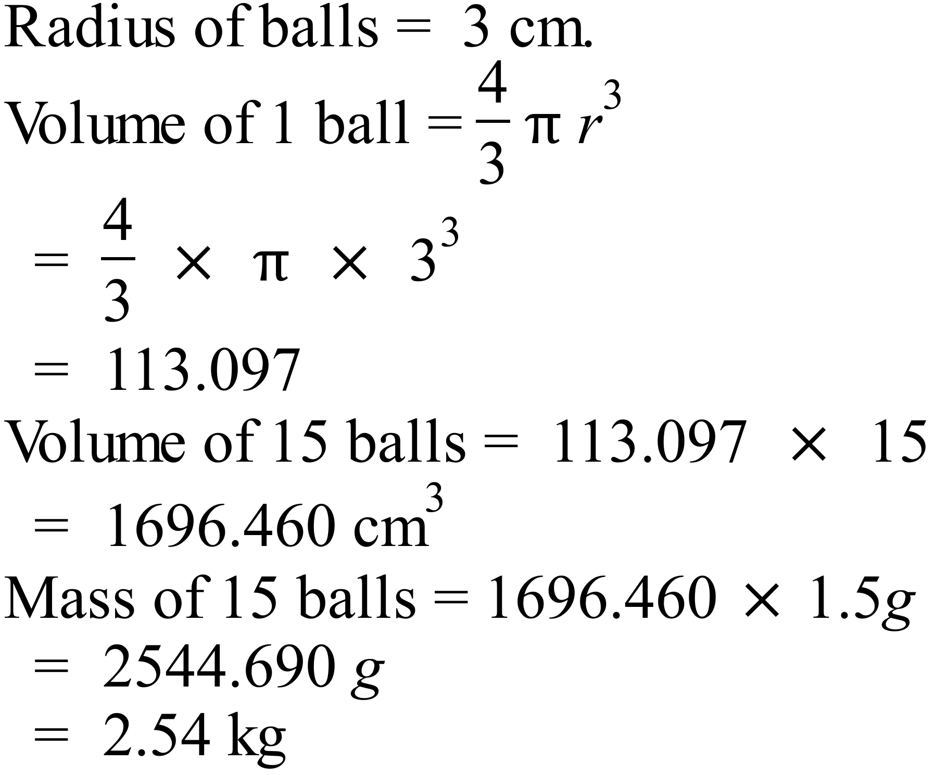 | D
61. | 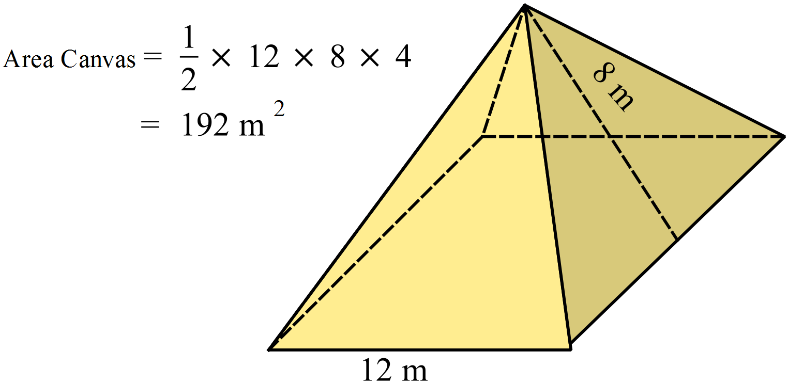 | A
62. |  | B
63. | 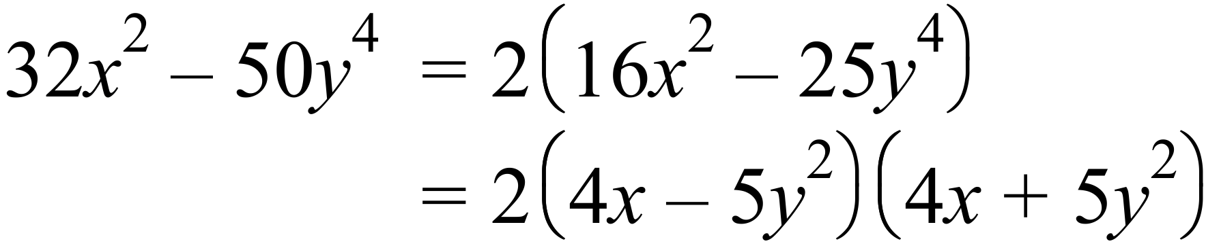 | D
64. | 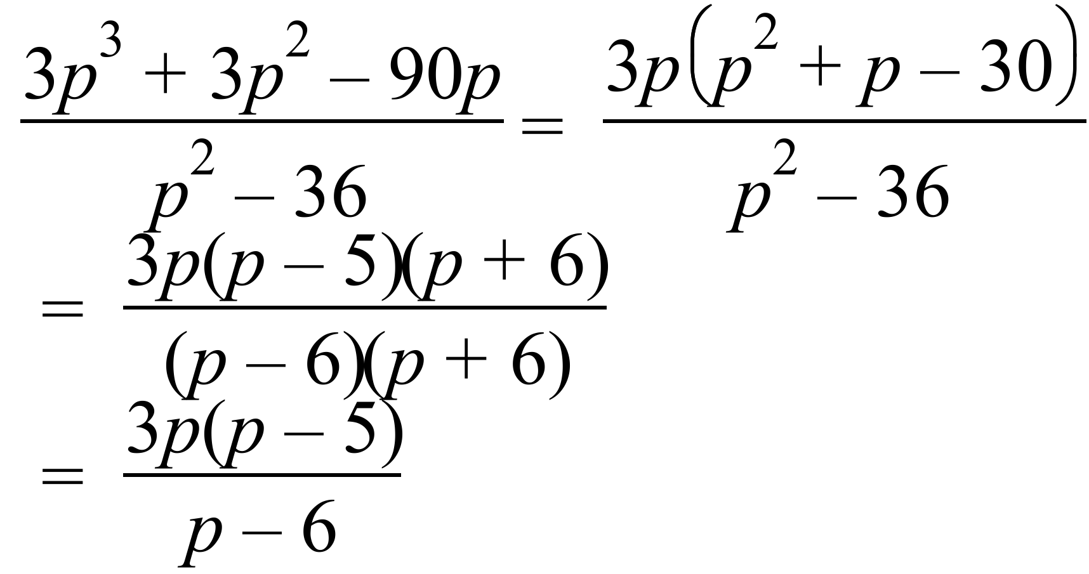 | A
65. | Line 4 should be | D
66. | Since it starts and stops above the axis and does not rise initially C is the only logical explanation. | C
67 | 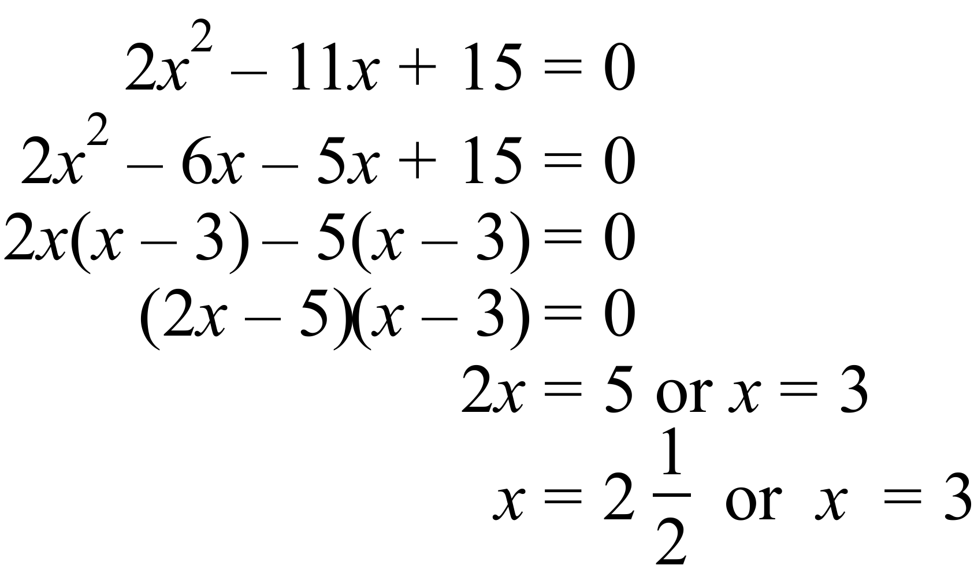 | B
68. | 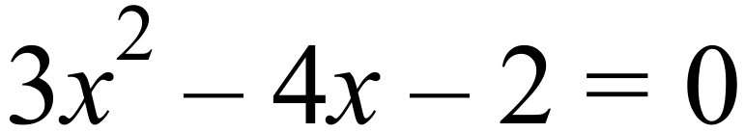  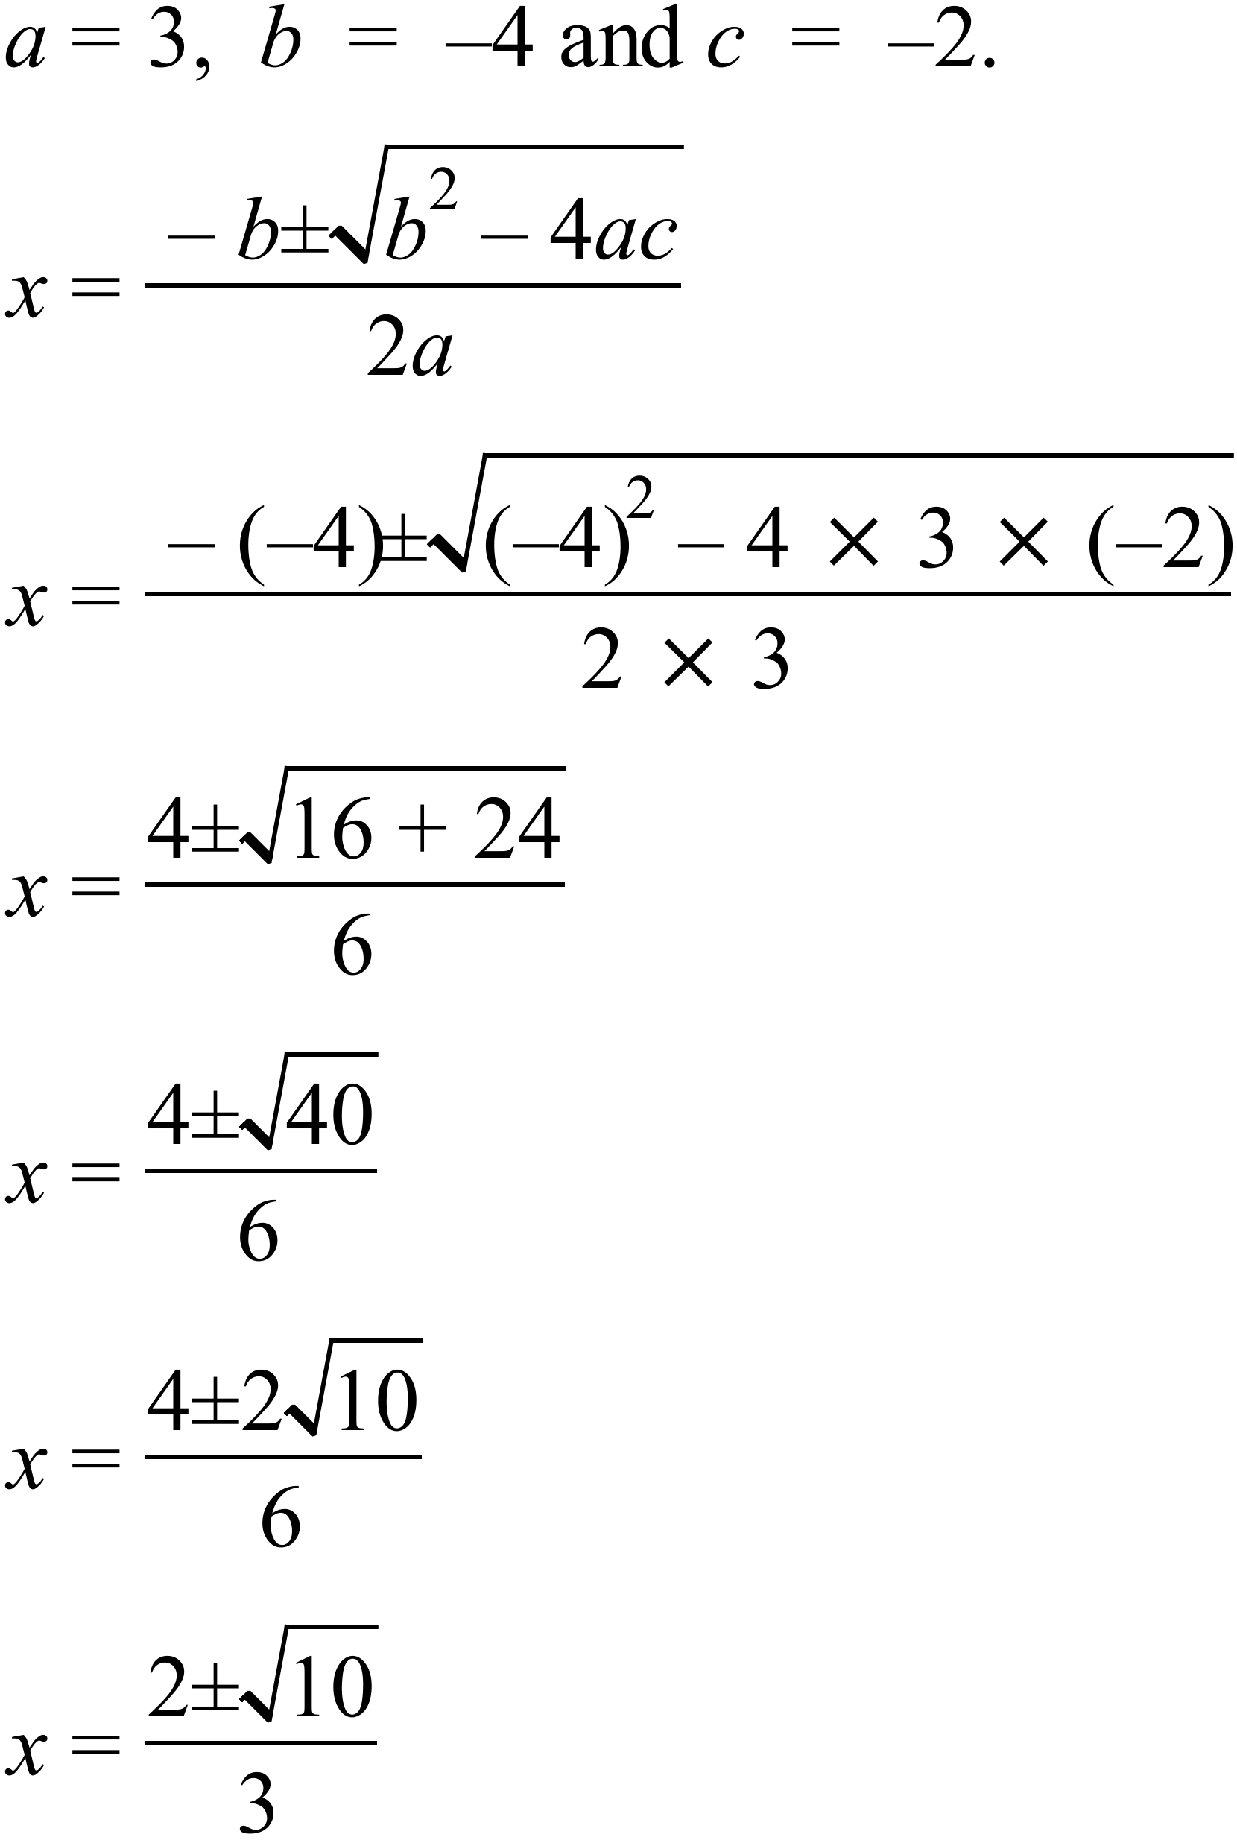 | B
69. | 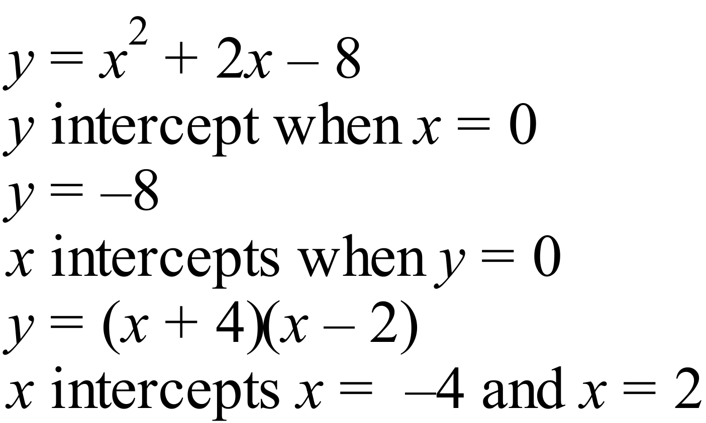  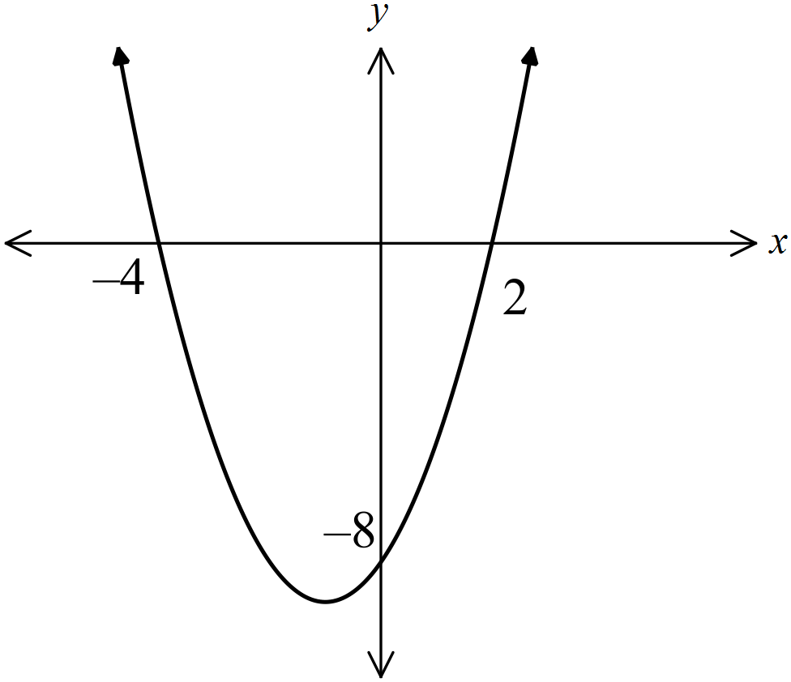 | C
70. | Shape is a cubic graph and since passes through (0, 1) and (-1, 0) it is 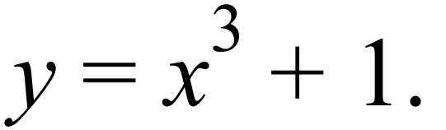  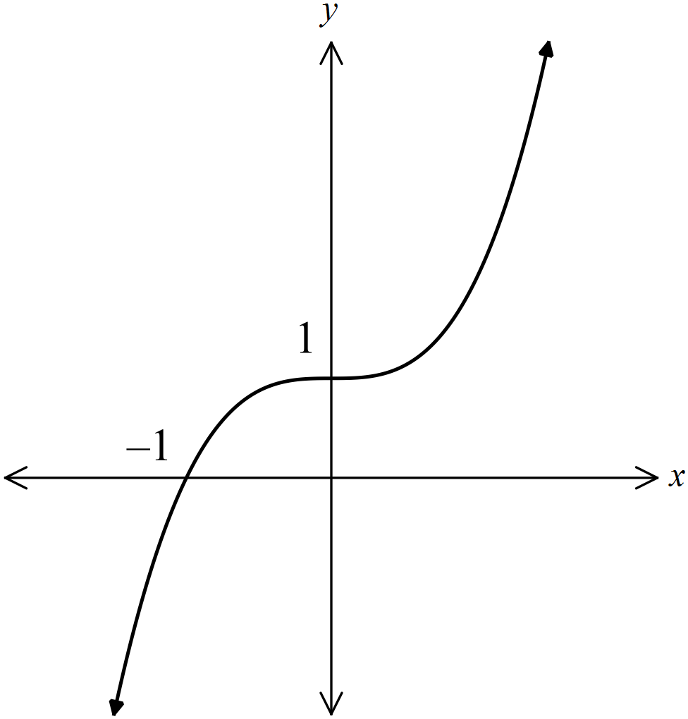 | C
71. | In the word EXCITEMENT, there are 10 letters of which 3 are E’s and 1 is an I.  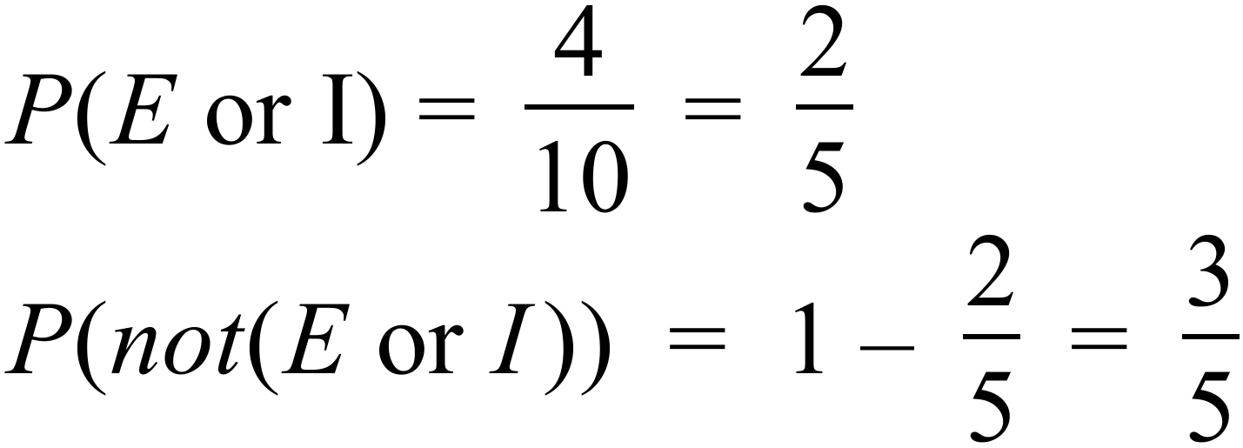 | D
72. | There are 70 people altogether, of which 12 are males with reusable bags.  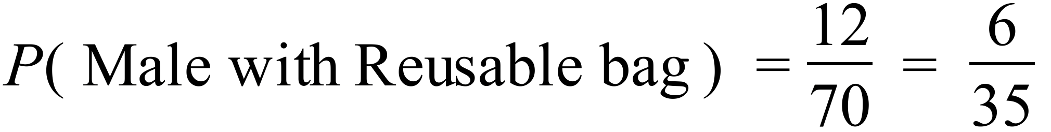 | A
73. | B shows there is a longer tail at one end and the median is not in the middle of the box, so is skewed.  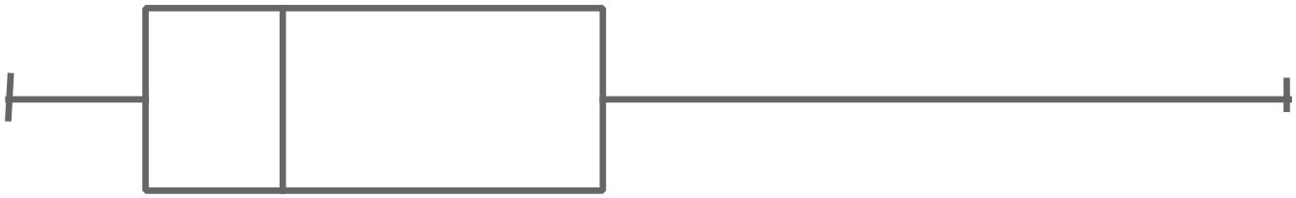 | B
74. | 18 scores, so median is between 9th and 10th scores which are both 7’s, so median is 7.  From bottom 9 scores, LQ is 5th score which is a 6.  From top 9 scores, UQ is 14th score which is a 9.  Interquartile range = 9 – 6 = 3 | A
  Frequency |  |  |  | O
  Frequency |  |  |  | O
  Frequency |  |  | O | O
  Frequency |  | O | O | O | O |  |  | O
  Frequency | O | O | O | O | O | O | O | O | O
  Frequency | 4 | 5 | 6 | 7 | 8 | 9 | 10 | 11 | 12
  Score
75. | From Calculator  Mean = 6.25 and standard deviation = 2.3 | A

Longer Answer Questions
76. a) | 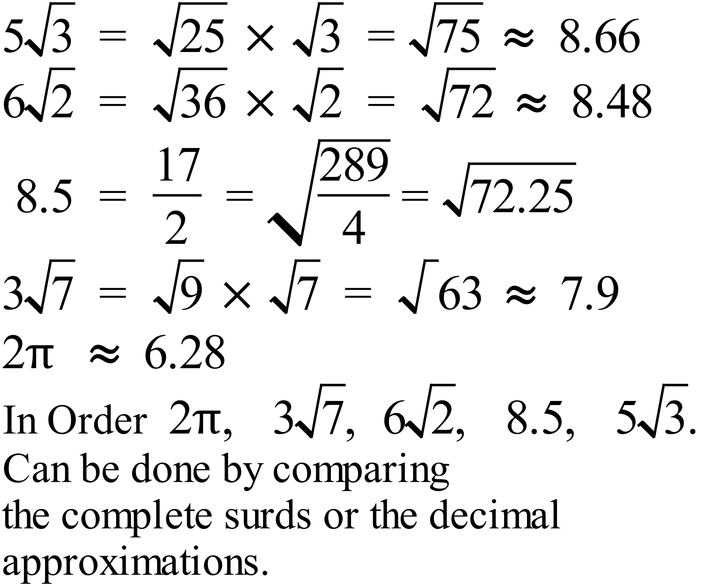 | 2 marks  Total  2 marks for correct order  1 mark if one out of place.
b) | 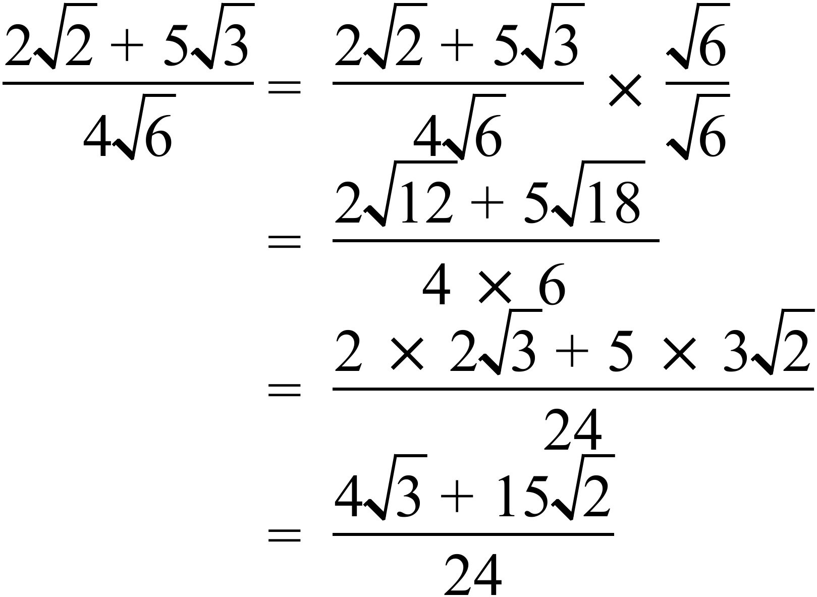 | 1 mark
77. a) | 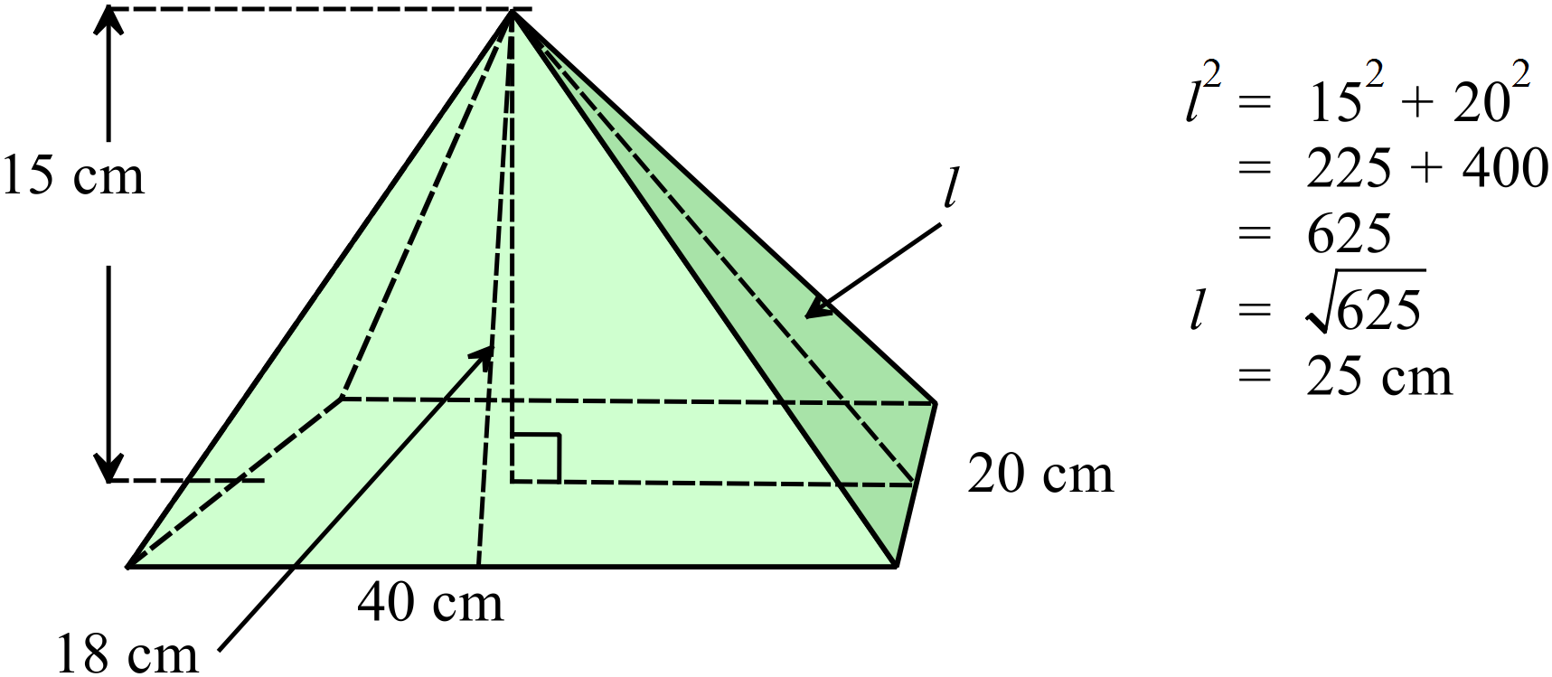 | 1 mark
b) | 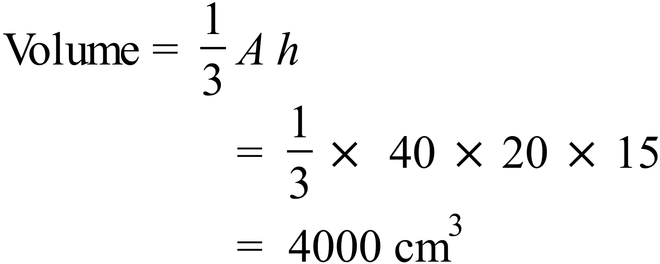 | 1 mark
c) | 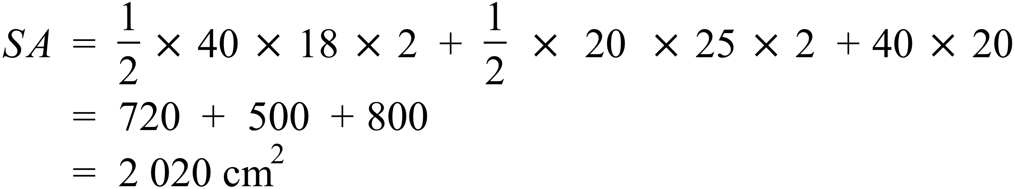 | 1 mark
78 | 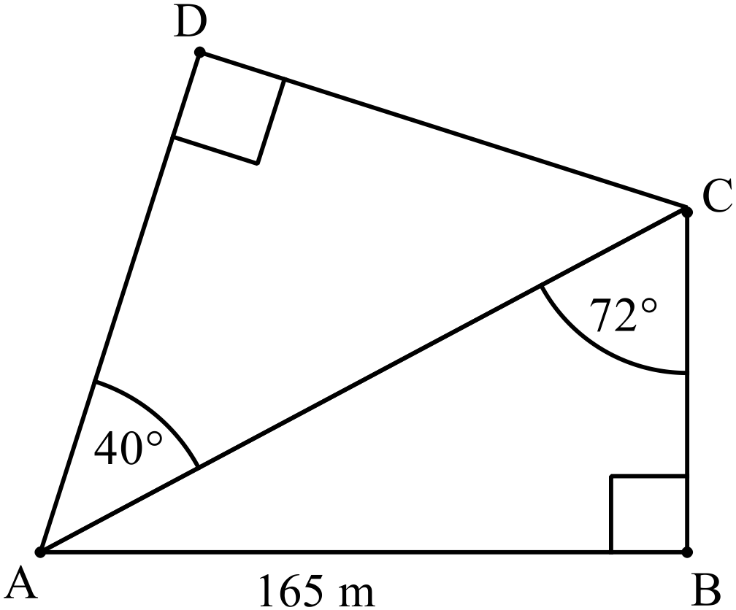  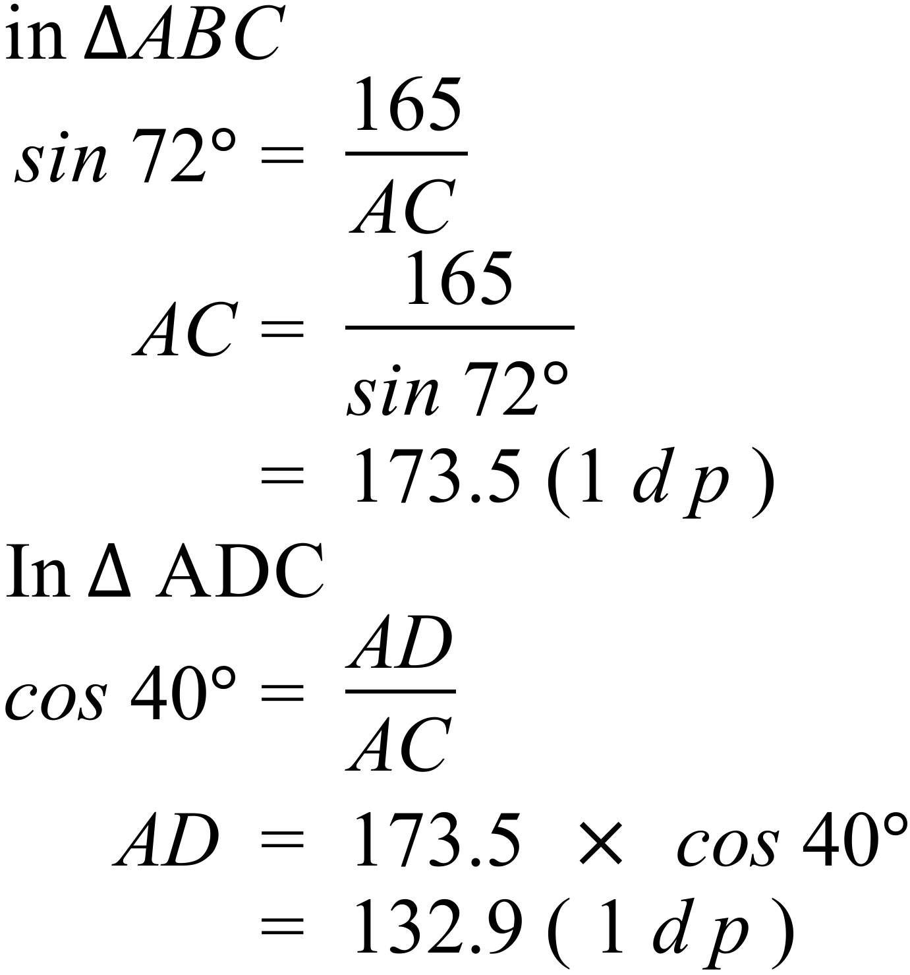 | 3 marks in total  3 marks for correct answer.  2 marks if either AC or AD working correct.  1 mark if some correct progress made.
79. a) | Principal =$6 000  4.4% p.a. compound quarterly = 1.1% per quarter.  r = 0.011  A term of 9 months = 3 quarters n = 3  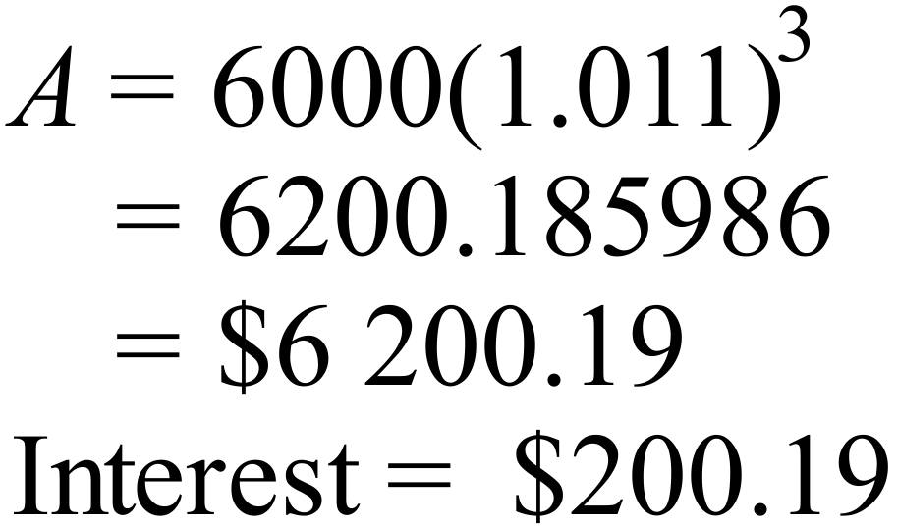 | 1 mark
b) | V = 680.00  18% p.a. compounded monthly = 1.5% per month  r= 0.015  6 months n = 6  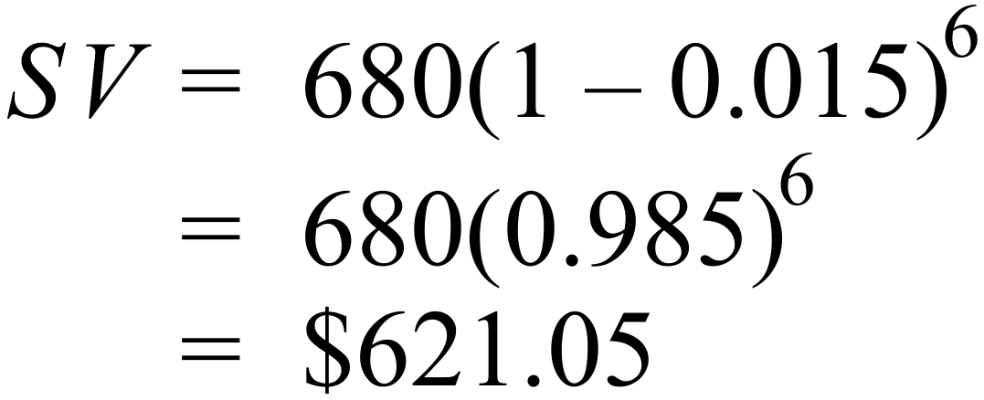 | 1 mark
80. a) | 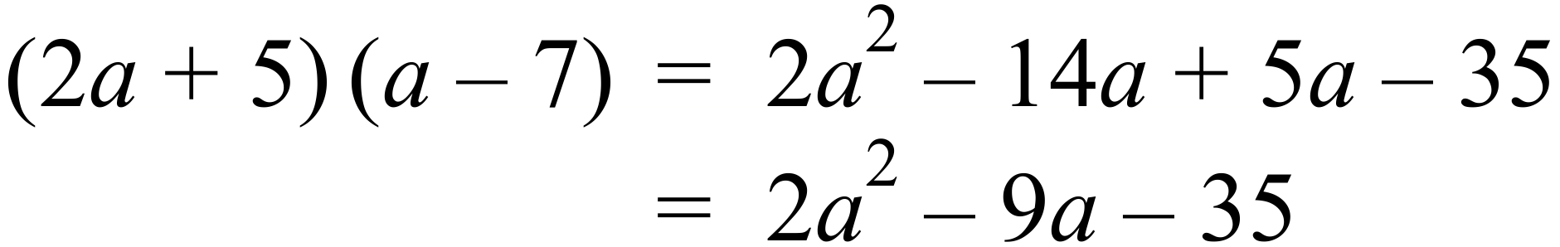 | 1 mark
b) | 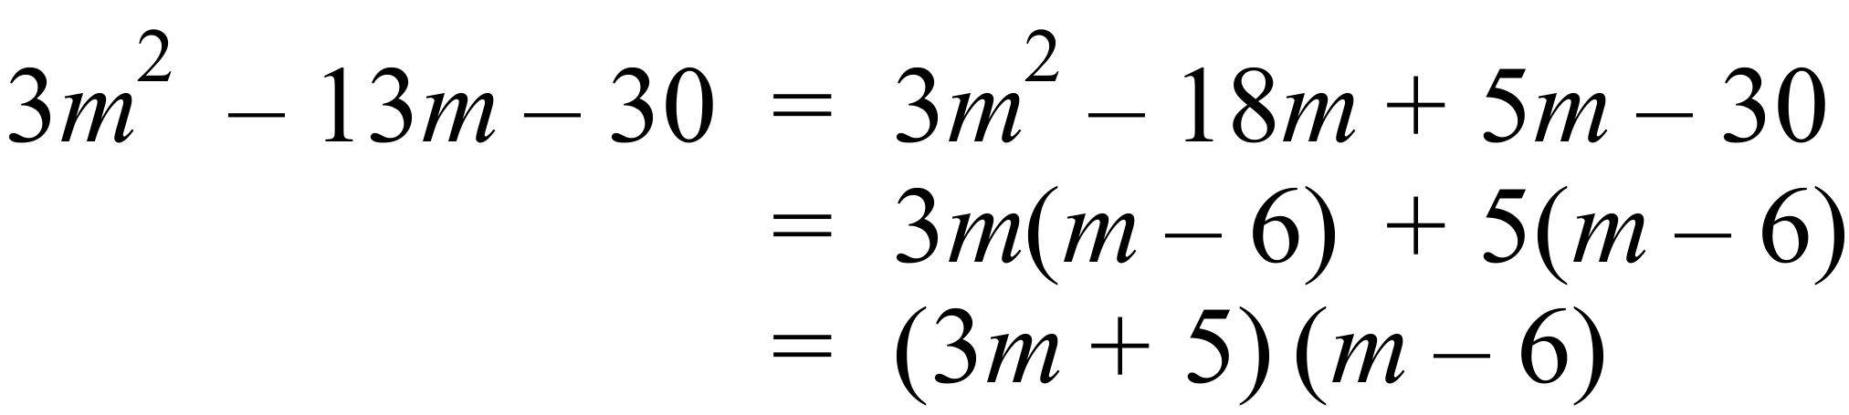 | 1 mark
c) | 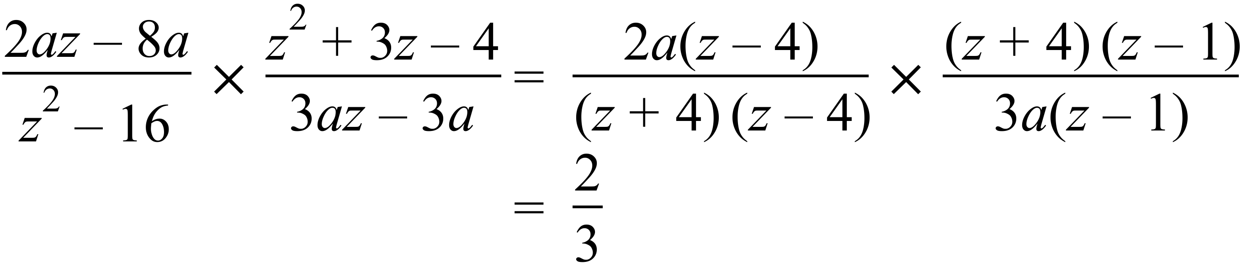 | 2 marks total  2 for correct answer.  1 for making some correct progress.
81 a) | 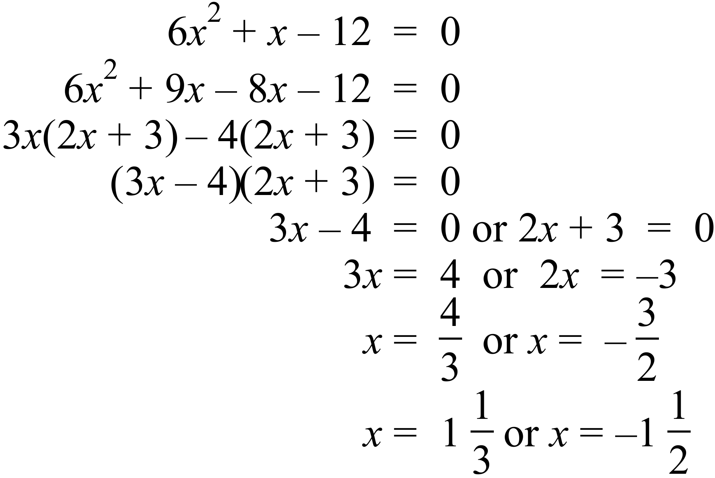 | 1 mark
b) | 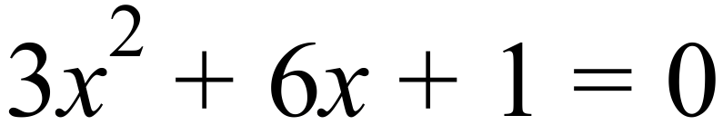  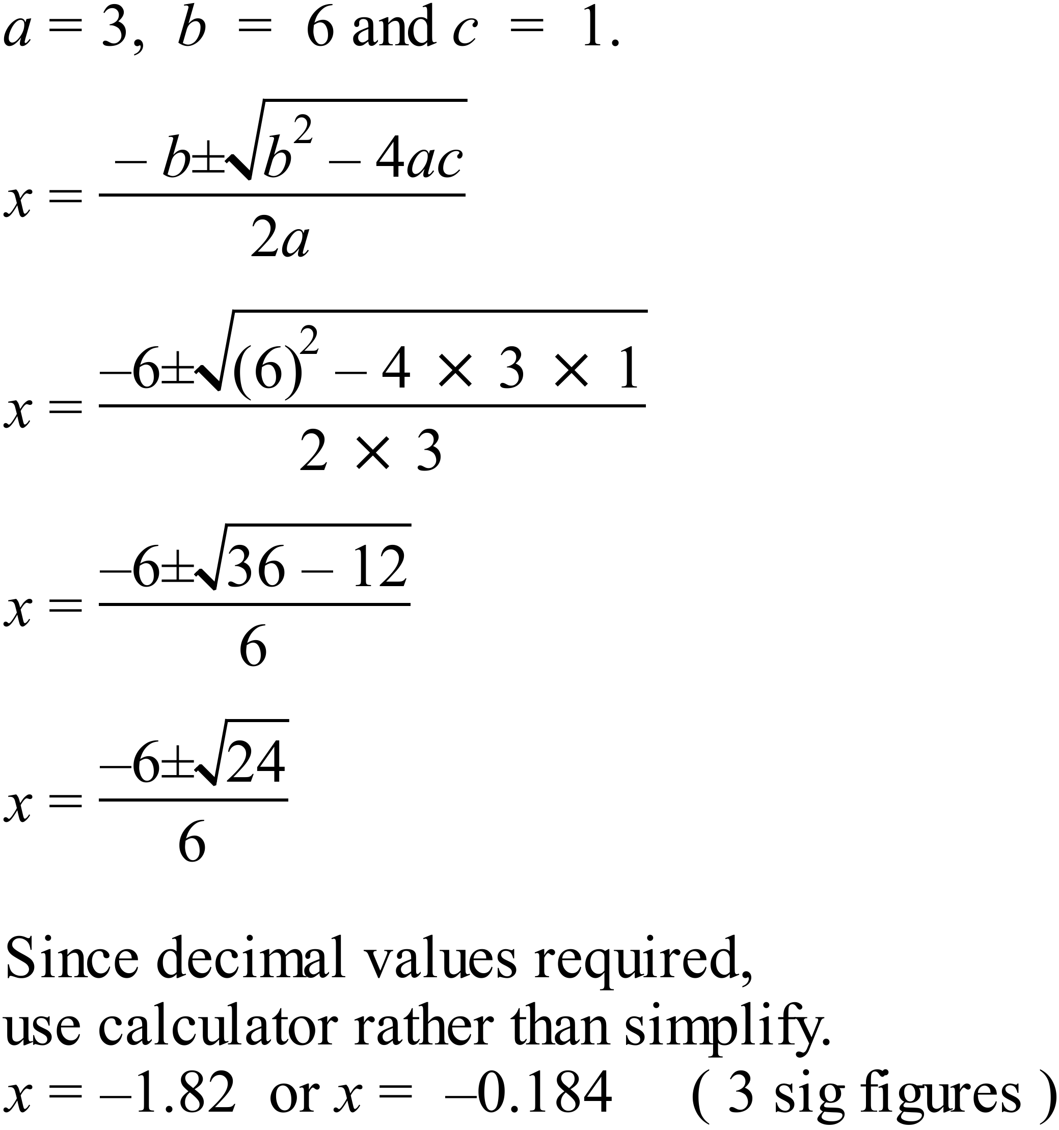 | 2 marks total  1 for surd value  1 for decimal to correct accuracy
82 a) | 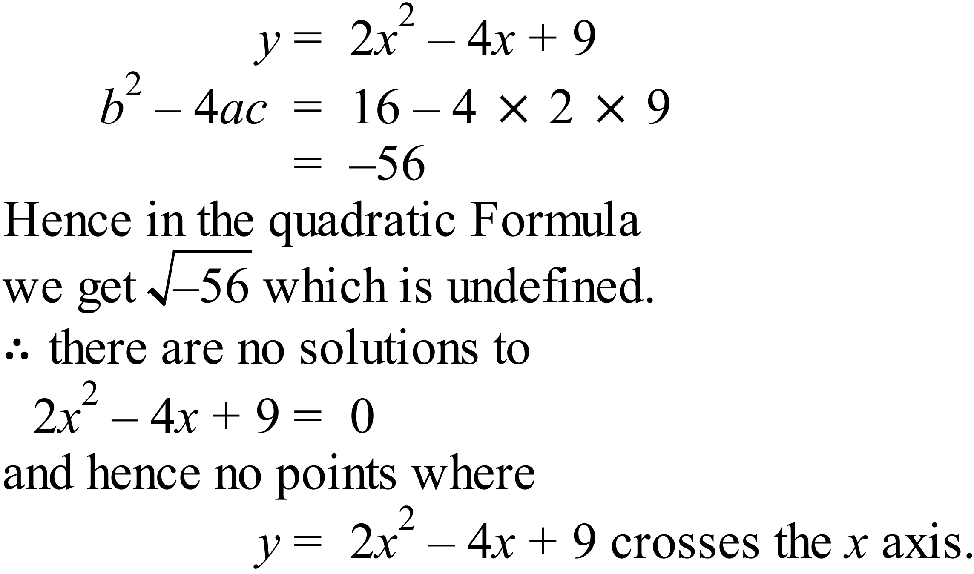 | 1 mark
b) | 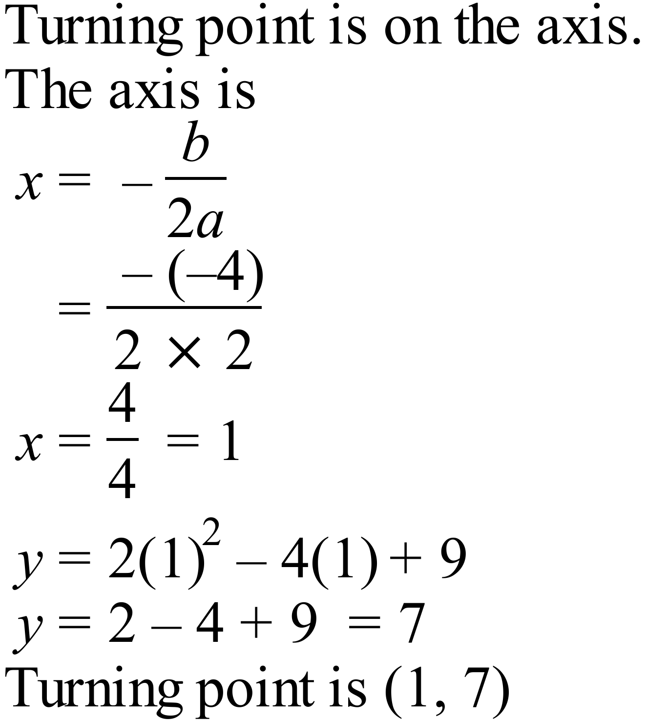 | 1 mark
c) | 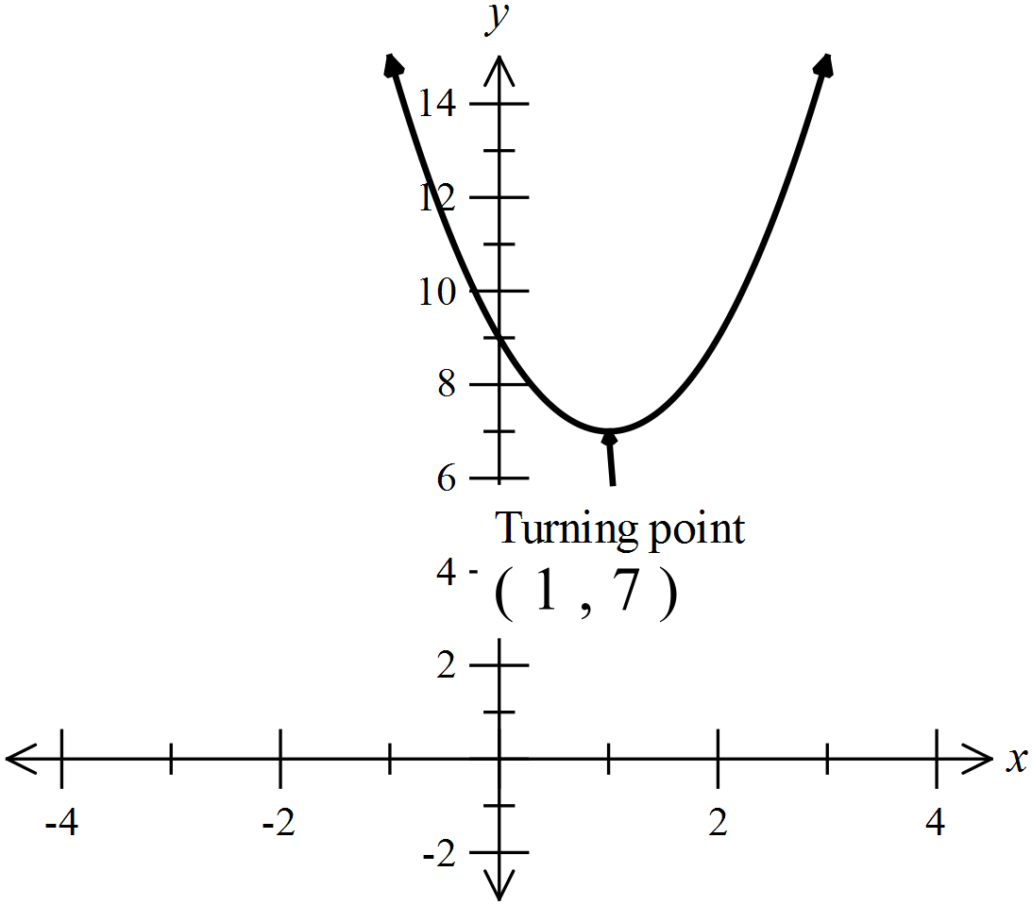  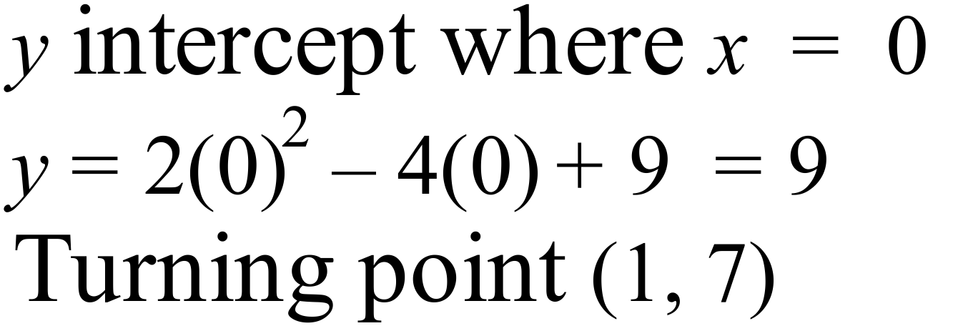 | 2 marks total  1 for correct shape  1 for y intercept and turning point
83 a) | From Calculator :  Group B  Mean = 24.25  SD = 15.4 | 2 marks total  1 for mean  1 for SD
b) | Group A  Mean = 34.1 SD = 15.0  Group B  Mean = 24.25 SD = 15.4  Group B has a significantly lower mean while maintaining a similar SD, however it is strongly skewed toward the lower values, while group A is symmetrical and clustered at the centre.  The medians (Group A 25 versus Group B 23.5) also suggest a lowering of the pain.  The quartiles show 75% are below 45.5 for Group A while 75% are below 36 for Group B.  It would appear that the drug has achieved the purpose of reducing pain as it gives significantly lower perceived pain. | 1 mark  1 for any valid analysis

High School
Half - Yearly Exam
Advanced Mathematics Course
Multiple Choice Section Answer Sheet
Name ________________________________ Teacher ________________________
Completely fill the response oval representing the most correct answer.

26. A B C D
27. A B C D
28. A B C D
29. A B C D
30. A B C D
31. A B C D
32. A B C D
33. A B C D
34. A B C D
35. A B C D
36. A B C D
37. A B C D
38. A B C D
39. A B C D
40. A B C D
41. A B C D
42. A B C D
43. A B C D
44. A B C D
45. A B C D
46. A B C D
47. A B C D
48. A B C D
49. A B C D
50. A B C D

51. A B C D
52. A B C D
53. A B C D
54. A B C D
55. A B C D
56. A B C D
57. A B C D
58. A B C D
59. A B C D
60. A B C D
61. A B C D
62. A B C D
63. A B C D
64. A B C D
65. A B C D
66. A B C D
67. A B C D
68. A B C D
69. A B C D
70. A B C D
71. A B C D
72. A B C D
73. A B C D
74. A B C D
75. A B C D

